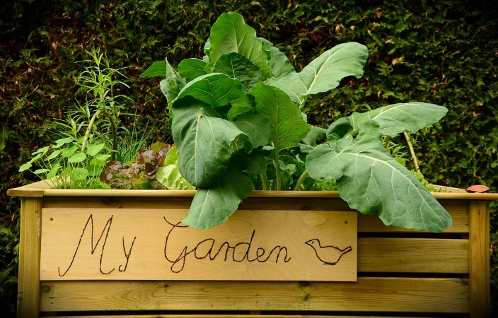
Going Back to Backyard Gardening

Saturday, June 29, 2019
9:00 am -11:00 am

‘The Well’
201 East 2nd Street
Walnut Cove, NC 27052

Attendees will receive an overview of traditional gardening, container gardening, and wildlife exclusion. The event will have hands-on building opportunities such as the construction of a raised bed. Demonstrations and presentations will be given by Bryan Hartman, Stokes County Cooperative Extension Agriculture and Natural Resources Agent. There will be chances to win garden goodies such as plants, tools and more.

The event is $5.
Register by contacting Bryan Hartman at bkhartma@ncsu.edu or (336) 593-8179.
*Dress accordingly for outdoor demonstrations*

Accommodation requests related to a disability should be made prior to the event by contacting Bryan Hartman, County Extension Agriculture and Natural Resources Agent, at (336) 593-8179 or bkhartma@ncsu.edu.

