Blueberry Production & Pruning Workshop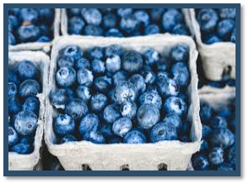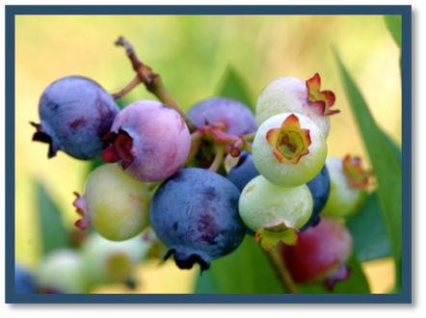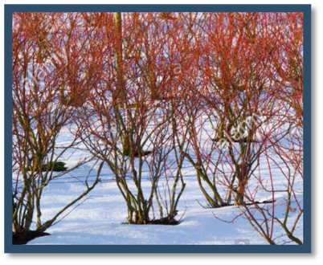

Saturday, February 23, 2019
1:00pm -3:00pm

Mabe’s Berry Farm
1695 Greenfield Road
Walnut Cove, NC 27052
Dress accordingly for outdoor demonstrations, weather permitting.

Cost is $10 and registration is required no later than Friday, February 22, 2019
to Bryan Hartman at bkhartma@ncsu.edu or (336) 593-8179.

All attendees will receive a free pair of pruners!!!

Accommodation requests related to a disability should be made prior to the event by contacting Bryan Hartman, County Extension Agriculture and Natural Resources Agent, at (336) 593-8179 or bkhartma@ncsu.edu.

