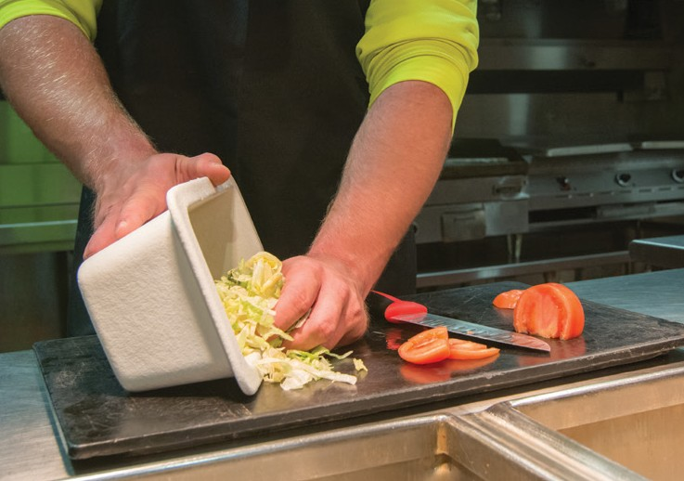

A training program for food protection manager certification

What is NC Safe Plates?
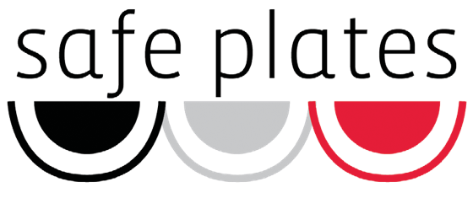
NC Cooperative Extension offers NC Safe Plates for all those who work in the food service industry. The course helps food establishments meet the North Carolina requirement of having at least one supervisor certified as a food protection manager, per the FDA Food Code 2013.

What information is covered?
NC Safe Plates includes instruction on personal hygiene and employee health; purchasing and storage; eliminating cross- contamination; handling allergens; pest control and facility design; cleaning and sanitizing and correct temperatures for storing, preparing and holding foods.

Who should participate?
This course is designed for food employees who are seeking food protection manager certification. Certification is based on passing the ANSI-approved exam from the National Registry for Food Safety Professionals. Certification is accepted throughout the United States for fi years from date of exam, and includes a certificate to be displayed in the workplace as well as a wallet card.

How is NC Safe Plates different?
NC Safe Plates is taught through case studies, storytelling, activities and discussion. This class is interactive and encourages participants to engage with the material.

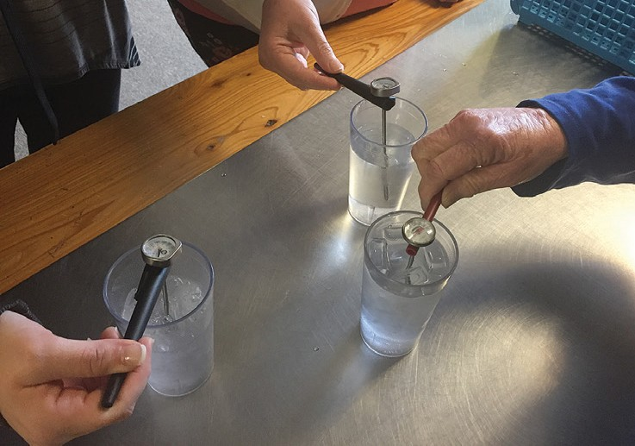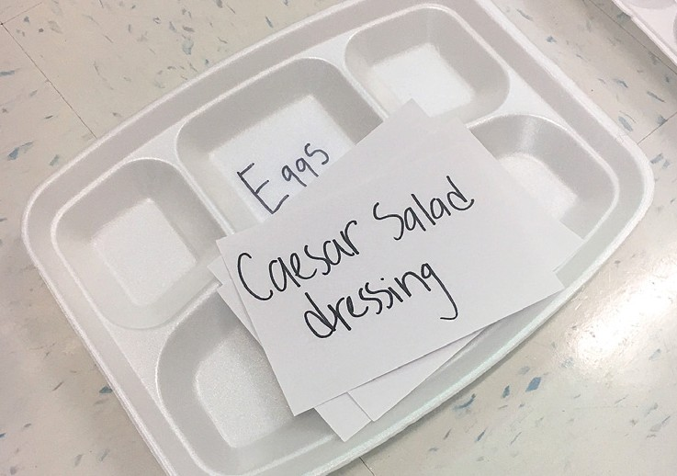

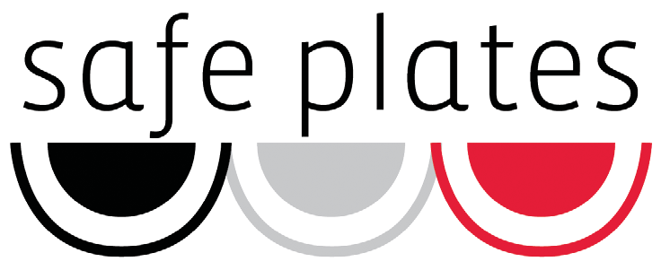

NC Safe Plates is a new food safety manager certifi course, developed and managed at NC State University and offered by NC Cooperative Extension Family and Consumer Science Agents for all those who work in the food service industry.
This course prepares food service managers to complete a nationally recognized, American
National Standards Institute Certifi Food Protection Manager certifi exam.
NC Safe Plates covers best practices for food safety management in a food establishment according to the 2013 FDA Food Code. The course is grounded in behavior change theory and adult education research. This interactive class encourages participants to engage with the material through case studies, storytelling and discussion.

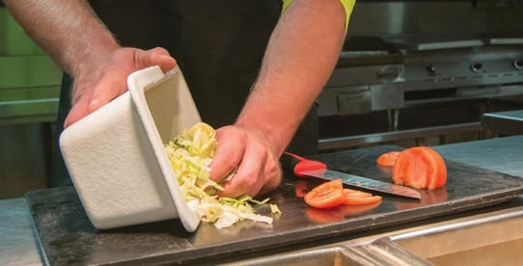
“A lot of information was given but in an easy way to remember...hands-on approach was helpful.”
“It refreshed my ways of thinking about food
safety both at home and at work.”
—NC Safe Plates participants

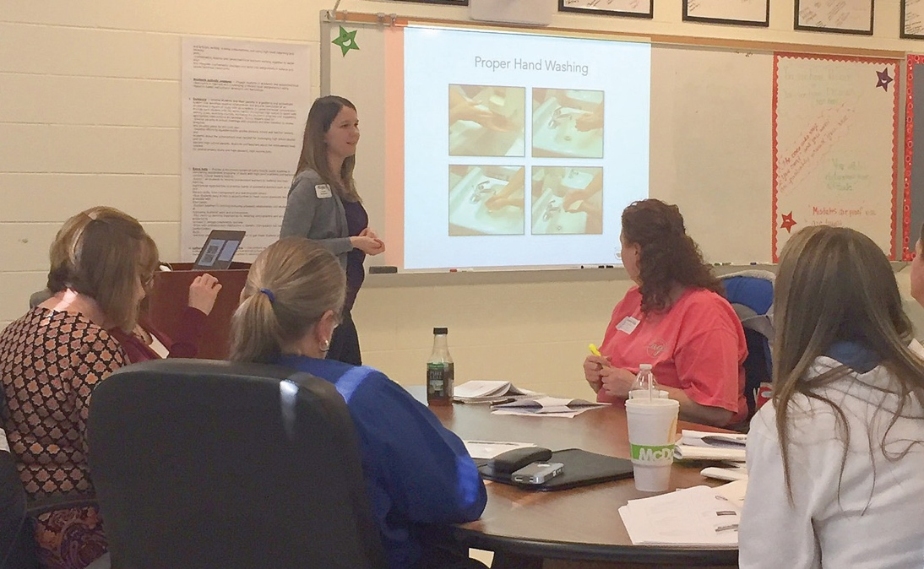
NC Safe Plates will be included as part of a foods based elective course in North Carolina public high schools beginning in 2017. This launch will include training 1,100 Family and Consumer Science teachers and is projected to reach 30,000 high school students per school year.
In 2015 and 2016, 55 Family and Consumer Science Agents were trained to deliver the program and 623 earned a Certifi Food Protection Manager certifi

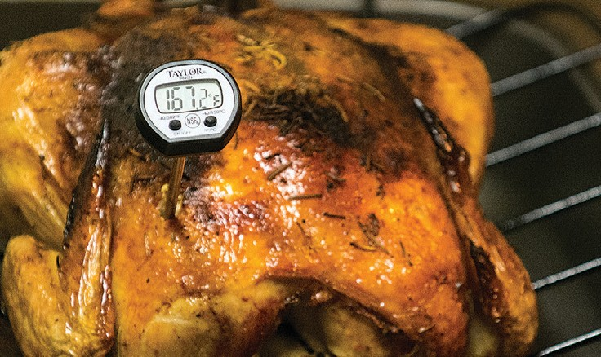

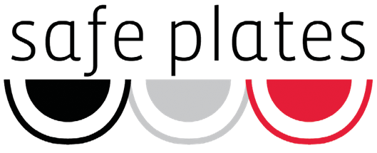
A training program for food protection manager certification
What is NC Safe Plates?
NC Safe Plates is a food safety certification course developed by NC State University. Certification is based on passing an ANSI-approved exam from the National Registry of Food Safety Professionals. Passing this exam satisfies the North Carolina requirement for a certification food protection manager.

Who should attend?
This is a comprehensive program for food service managers and supervisory staff in restaurants, hospitals, nursing homes, schools and other food handling establishments.
Class:
March 18-19, 2019 9am-4:00pm*
*with one-hour lunch break on your own
Exam:
March 20, 2019 9am-12noon
Address: Stokes County Cooperative Extension, 700 North Main Street, Danbury, NC 27016

Registration Fee: $125
Registration forms and payment must be received no later than Monday, February 18, 2019.

Send Registration to:
Stokes County Cooperative Extension PO Box 460
Danbury, NC 27016
Contact Info:
Patti Snyder, Family & Consumer Sciences Agent at
(336) 593-8179 or pebruce@ncsu.edu

Accommodation requests related to a disability should be made to Patti Snyder at (336) 593-8179 or pebruce@ncsu.edu.

Safe Plates Registration Form

Name
Phone
Home Address

City, State, Zip

Email

Business Name
Phone

To be completed by Extension Office Check Money Order Amount Received

