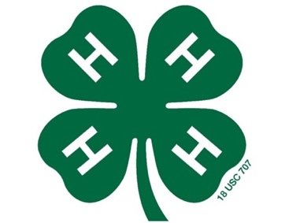

2019 Eastern Carolina 4-H Livestock Show & Sale
Participant Entry Information

Participant Name: ______________________________ DOB: _______________

Age Category: ___ Cloverbud (5-7yrs) ___ Junior (8-10yrs)
(as of Jan 1, 2019)
___ Intermediate (11-13yrs) ___ Senior (14-18yrs)

Mailing Address: ____________________________________________________

Parent(s) Name: ____________________________________________________

Parent(s) Email: ____________________________ Parent Phone: ____________

Participant Email: ______________________ Participant Phone: ____________

Have you participated in this show & sale before? ____ yes ____ no

What Species are you planning to show?

____ Goat ____ Lamb ____ Hog ____ Steer

Do you need help locating an animal? ____ yes ____ no

Preferred method contact: ____ Email _____ Text _____ Phone

