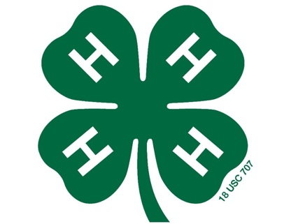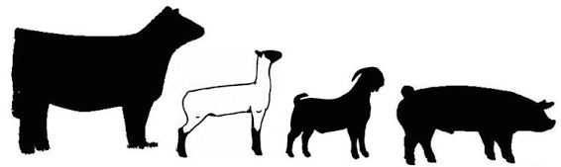

New to the 4-H Livestock Program?
Quick Facts

- What is a 4-H Livestock Project?
4-Her's involved in the livestock program are challenged with real-life issues as they learn responsibility through raising, showing and judging livestock. Livestock projects give students the opportunity to practice and acquire new knowledge in the fields of animal science, business, time management and leadership.

- How to Begin:
- Commit to the project! This is a 60-day project (120 days for cattle) that requires lots of dedication and hard work to do a good job. Parents also need to be supportive and willing to help.
- Decide what kind of animal you’d like to show – goat, lamb, hog heifer or steer.
- Do your homework! Talk with your extension agent, experienced parents and participants, and local farmers for advice on how best to take care of the animal to complete a successful project. Research and learn about the animal you’ve chosen and how best to take care of it to get it ready for the show.
- Find an animal. Buying from stockyards is not recommended due to the risk of sickness or disease. There are reputable people/farmers that breed show animals so ask other experienced participants and parents and work with your extension agent to find an animal that would be a good fit for your child. It’s also not a bad idea to bring your animal home a few weeks before the project begin date so it can settle in and get to know you before you start working with it.

- Records Books:
Each participant (including Cloverbuds) are required to complete a 4-H Record Book on their project. This involves keeping records of feed given, costs incurred, how they work with their animal, things they’ve learned, etc . . . . Pictures should be taken throughout the project as well.

- How the Show Works:
The participants bring their animals early on the morning of the Show day and put the finishing touches on their animals in the afternoon. Class divisions are:
- Showmanship for Cloverbuds – Participants ages 5-7 can participate project where they care for and work with a goat or lamb. They will “show” in a Cloverbud showmanship class (participation only awarded) where they can practice their showing skills and knowledge of their project by answering questions from the judge. This is a great skills practice for competing when they reach Junior Division age.
- Showmanship – Junior (ages 8-10), Intermediate (ages 11-13), and Seniors (ages 14-18) compete in classes according to their age divisions where they exhibit their skills handling their animals and share the knowledge of their project with the judge. Conformation and condition of the animal is not judged.
- Market Classes – each species, divided into weigh classes within species, are judged on physical traits such as structural correctness, muscling, style and balance and the individual animals are placed in order of judge’s preference. Cloverbuds do not compete in these classes.

- How the Sale Works:
- Animals exhibited by youth in the junior, Intermediate and Senior divisions may be sold in the Auction. (Cloverbuds may not participate in the sale.)
- Families must secure their own “bidders” for the auction before the actual event. Participants should write letters to prospective supporters detailing their project and what it is teaching them and deliver them in person. Typically, businesses your family supports are the best to approach – Farm Bureau, feed, equipment, & fertilizer companies, family-owned businesses, etc . . . are very supportive of the sale. Again, work with your extension agent and experienced participants and parents to come up with a plan to get the most out of your project.
- You may either sell your animal to the stockyard for market price (in addition to the price earned at the sale) or you may take your animal home, but it must be declared at weigh-in at the sale and cannot be changed.
- The amount of money earned after expenses will greatly vary and depends on how hard the participant works to secure “buyers” to support their animals at the sale.

- Recommendations:
- Work hard!
- Enjoy working with your animal!
- Don’t be afraid to ask LOTS of questions and ASK for help when you need it!
- Participate in all the workshops and clinics that are offered!
- Don’t be disappointed if you don’t win anything your first year – you are a WINNER just by completing the project taking the best care of your animal that you can!

Most importantly, HAVE FUN!

