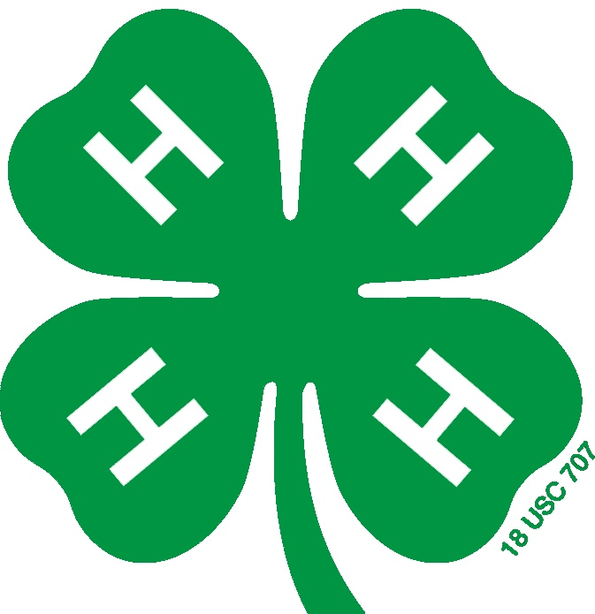
Junior Hog Animal Record – Ages 8-12
Halifax County Livestock Program

- Hog Information

Tag or ID #:
Breeder Name & Address:

Breed:
Date of Birth:
Total days on feed:
Beginning Weight:
Final Weight:
Total Weight Gain:
(Answer B – Answer A = Answer C)

- Feed Purchased and Cost
Date | Name of Feed | Pounds (lbs) Purchased | Cost per lb | Total Cost

Total lbs of Feed (D) = __________
Total Cost of Feed (D x Cost per lb=E)=___________

- Other Costs:
Cost of Animal (F)
Cost of Minerals, Vitamins, Salt (G)
Vet Cost (Vaccine/Dewormers etc.) (H)
Entry Fees, hauling, show supplies, other costs (I)
Total Other Costs (F+G+H+I)=(J)
Total Feed and Other Costs (E+J) =(K)
- Income:
Market Sale Price:
($ per lb X Final Weight) (L)
Income from Sponsorships: (M)
Other Prizes: (N)
Total Income: (L+M+N) = (O)
Total Cost: (from section 3) (K)
PROFIT OR LOSS
(O-K) = (P)

- Performance Record:
Total Weight Gain:
(From section 1) (C)
Total Days on Feed:
(From section 1) (Q)
Average Daily Gain:
(C / Q) = (R)
Feed per lb of Gain:
(D / C) = (S)
Cost per lb of Gain:
(E / C) = (T)

- YOUR Time with Your Project
Hours Spent – General Care (Feeding, watering, etc.) (U)
Hours Spent Working with Animal/Practicing (V)
Hours Spent Preparing for Show (Washing, clipping, etc.) (W)
Other Hours Spent (Deworming, etc.) (X)
Total Number of Hours Spent on Project Animal (U+V+W+X) = (Y)

- Describe the facilities where you housed your hog.
______________________________________________________________________________________________________________________________________________________________________________________________________________________________________________________________________________________________________________________________________________________________________________

- What does a judge look for in placing market hogs?
______________________________________________________________________________________________________________________________________________________________________________________________________________________________________________________________________________________________________________________________________________________________________________

- What was the breed composition of your hog, and why did you choose that?
______________________________________________________________________________________________________________________________________________________________________________________________________________________________________________________________________________________________________________________________________________________________________________

Ear Notching Practice
Draw in “notches” on the pig for its respective identification number.

NC State University and N.C. A&T State University are collectively committed to positive action to secure equal opportunity and prohibit discrimination and harassment regardless of age, color, disability, family and marital status, gender identity, genetic information, national origin, political beliefs, race, religion, sex (including pregnancy), sexual orientation and veteran status. NC State, N.C. A&T, U.S. Department of Agriculture, and local governments cooperating.

