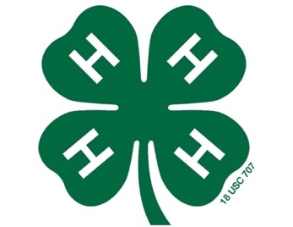

2019 Eastern Carolina 4-H Meat Animal Show & Sale
Halifax County Participants

IMPORTANT DATES
- November 27th @ 4pm-6pm – Steer Weigh-In

- January 12th @ 10am - Record Book Workshop

- January 28th @ 4pm-7pm – Lamb, Goat & Swine Weigh-In

- February 5th @ 6pm – Youth Quality Care of Animals Workshop – Ages 8-18

- February 23rd @ 10am – CLOVERBUD YQCA Workshop

- March 3rd – Cloverbud animals must be officially entered checked in by extension

- March 5th @ 6pm – “Marketing Your Animal” workshop & final show meeting

- March 9th – Showmanship Clinic

- March 30th & April 6th @ 8am – Arena Clean-up
(Participants are required to attend one of these days)

- April 2-3, 2019 – Show and Sale!

- May 17th – Livestock Project Record books due to Extension office

