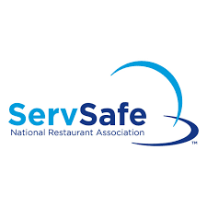
ServSafe Class
Monday & Tuesday
October 14th & 15th
9am – 4pm each day Registration Due Exam
Monday, Wednesday,
September 30th October 16th @ 9am

Student’s Name: ____________________________________________________

Student’s Home Address: _____________________________________________

Establishment’s Name & Address: ______________________________________

Student’s Cell Number: _______________________________________________

Registration Fee Schedule:
The $135 registration fee includes the 7th Edition Manager Book, exam sheet, study materials and supplies. A late fee of $20 will be applied to any registration form received after September 30th.

Make checks payable to Pasquotank Farm Services
Mail payment and registration form to:

Pasquotank County Extension Center
Post Office Box 1608
Elizabeth City, NC 27906-1608
Phone: 252-338-3954

