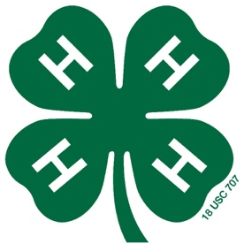

Stokes County 4-H Nutrition Fair
Entry Form
January 19th, 2018 at 6:30PM
Stokes County 4-H Office
RETURN BY: January 10th at 5PM

Name: ________________________________________________________________________

4-H Club (optional): ___________________________________________________________

Age Division: 5 – 8 ______Cloverbuds
(check one)
9-13 _______Juniors 14-19 _______Seniors
Please return this form along with your recipe (typed or printed legibly) by January 10th.
Can also email recipe!

Taylor Furr
700 N Main St
PO Box 460
Danbury, NC 27016
336-593-8179 phone
336-593-8790 fax
tfurr@ncsu.edu

Category:
(check one)
_______Snacks

_______Beverage

_______Main Dish

_______Bread

_______Salad

_______Dessert

