Upcoming Programs and News For
Catawba Valley Cattlemen’s Association Members
And Livestock Producers Through-out the Valley
Catawba Valley Cattlemen’s Association Meal and Meeting
Tuesday, May 10, 2016
5:30 PM Meal 6:15 PM Meeting
Forage Management Saves Hay Cost
There will be two special speakers at this meeting and a regular business session. Mr. Keith Caldwell will discuss the advantages of planting cool-season/warm-season annual forage species to offset the shortages caused by the natural cycle of fescue (the most used perennial grass in our area). Mr. Jerry Mackie will share his experiences with saving money by planting a cool-season annual to offset the low production of his fescue pastures caused by last year’s drought. He saved approximately $10,000 in hay costs! Come learn how to apply his experience to help your forage production system become more profitable. A NCSU handout on the subject will be available at the meeting. Please prepare for the meeting by reading the enclosed article, Design a Forage Production System for Your Farm.
Scholarship Opportunity for Local High School Seniors
If you have any high school seniors who would like to apply for the CVCA scholarship, please call the Catawba County Extension Office at 828 465-8240 to request forms. The deadline for receiving applications is May 20, 2016. A committee will spend an afternoon interviewing students the following week.
The Scholarship Committee will meet immediately after the meeting to discuss business and set student interview dates. The primary duties are spending one afternoon interviewing students and deciding who gets the scholarships. The committee members are: Dean Crocker, Steve Kale, Jeremy Lee, Steve Killian, Guy Brown, Gerald Frye, and T.W. Wall. Incoming members include: Clarence Hood, Ken Man Freddie, and Howard Reinhardt.
Cattle Marketing Seminar Thursday May 5th starting with a free meal at 6:00 pm. Sponser & Location: Cleveland County Agriculture & Livestock Exchange; Shelby, NC.
Design a Forage Production System For Your Farm
Works For Any Size Herd & Saves Money!
Glenn Detweiler
When you begin designing a forage program, keep in mind the following:  ■ Use forage species (Table 1) with growth  patterns (Fig. 2) that provide forage for  most of the year to develop a year-round  grazing system.  ■ The relative nutritive value or quality  of forage is as important as the quantity  produced. Pasture quality is directly  related to several factors: fertilization,  forage species selection, stocking rates,  the growth stage of the forage, and the  environment. Fortunately, we can control  most of these with careful attention to  sound management practices.  (Note: hay is always lower in nutritive value than the same forage grazed.)  - Perennial plants should be the foundation of a permanent pasture system. Whenever soil and climate permit, cool season grass-legume mixtures are preferred to pure grass stands. The legume component can fix atmospheric nitrogen, therefore reducing the need for applying nitrogen fertilizer to the pasture (Fig.1).  - A combination of cool- and warm-season grasses in separate stands in a pasture system will provide a more even supply of forage and lengthen the grazing season. An ideal pasture system would include 50% - 75% cool-season forages with the balance in warm-season grasses. | 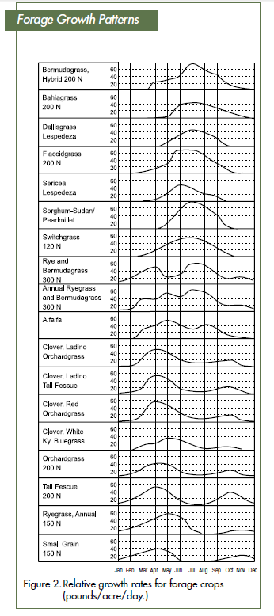  Jan Feb Mar Apr May Jun Jul Aug Sep Oct Nov Dec
- Temporary pastures are good for eliminating endophyte infected fescue pastures over a
two year period and fulfilling emergency needs. Planted annually, they are usually
available within one to two months after planting, then used for six to eight months. Small grain cool-season annuals such as rye, oats, wheat, and perennial ryegrass (a perennial which grows like an annual in North Carolina) are typically used for temporary pastures in late fall and winter. They may be interseeded into Bermuda grass or other warm-season pastures, or they may be planted alone in September to provide quality grazing from December through May. Warm season annuals normally need to be planted alone.
The proper combination of permanent and temporary pasture will provide almost year-round grazing under ideal conditions. Only a limited supply of hay will be required in a properly managed pasture system, used during excessive snow cover, periods of unseasonably cold temperatures, and drought.
