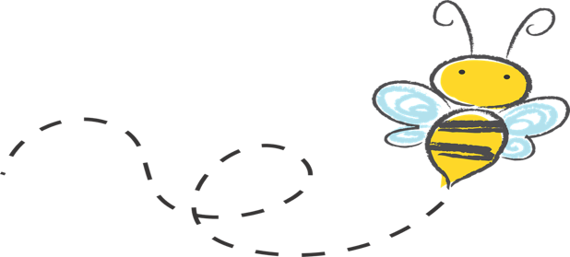
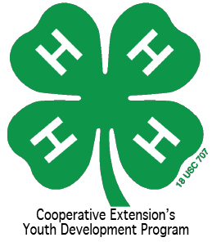
The afterschool program offers offers a safe care through structured and supervised educational and recreational activities. Children are able to establish lasting and productive friendships. Every child’s interest is captured through a wide range of program topics such as drama, cooking, arts, crafts and much more.
  - Volume 1 | Issue 1
October 3, 2016
Gates County
4-H
Keli Boone, 4-H Agent

252-357-1400

keli_boone@ncsu.edu

http://gates.ces.ncsu.edu
Facebook: Gates County 4-H

112 Court St
P.O. Box 46
Gatesville, NC 27938

What ’s Buzzing in Afterschool????

Upcoming Events
  - October 3-7- Teacher rotation begins
  - October 2-8 National 4-H Week
  - October 13-23 NC State Fair
  - October 15th- Billing due
  - October 19th - Early release and pumpkin decorations at Gatesville Elementary
AFTERSCHOOL STAFF
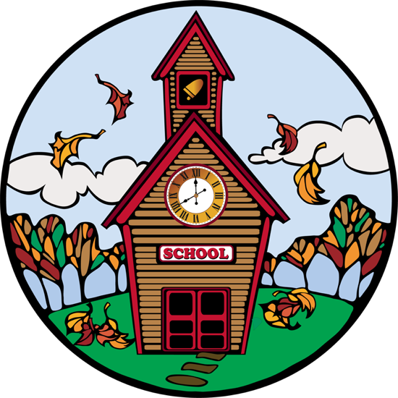

- Tracey Carr
- Margie Copeland
- Junee Nelson
- Mamie Wilson

North Carolina State University and North Carolina A&T State University commit themselves to positive action to secure equal opportunity regardless of race, color, creed, national origin, religion, sex, age, or disability. In addition, the two Universities welcome all persons without regard to sexual orientation. North Carolina State University, North Carolina A&T State University, U.S. Department of Agriculture, and local governments cooperating.

