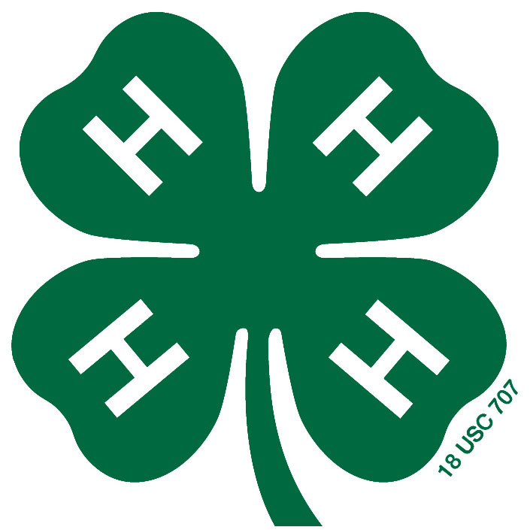
Brunswick County 4-H Fair Board

Dear Madam or Sir,
President
Agnes Taylor

Vice President
George Wong Chong

Treasurer
Benji Jones

Judge Coordinator
Agnes Taylor

Youth Members
Kaitlin Jones
Rebekah Taylor
Nationwide, 4-H alumni report that the county 4-H fair was one of the most important and memorable events in their 4-H experience. Youth learn to take pride in their work, show it to the best of their ability, and accept feedback all while demonstrating good sportsmanship at county 4-H fairs. Please help us celebrate our youth and their successes.

In 2013, we held the first Brunswick County 4-H Fair. Twenty-five youth participated and received rating and championship ribbons sponsored by Brunswick County Farm Bureau. In 2014, community members and businesses sponsored the event and we were able to add cash prizes for every class and division winner. Your generosity helped 4-H members fund their projects.

We would like to continue to provide a premium to each class winner. In order to accomplish that, we are asking local businesses and community members to sponsor classes in the fair again this year. A donation of at least $20 will sponsor the premium for the Junior (3rd-8th grade) and Senior (9th-13th grade) class prize and give your business card a spot in our sponsor book. Copies of the sponsor book will be given to each participating business to distribute and display. They will be passed out at the county 4-H fair and on the 4-H website as well.

If you are able to sponsor a class, please complete the attached paper work and return it by mail by July 31st, to:
Brunswick County 4-H Fair Board
c/o Elizabeth Jones
1102 Gilbert Road
Bolivia, NC 28422

Please make all checks payable to The Brunswick County 4-H Fair Board and include your business name in the memo line if it is not on the check.

Sincerely,

Agnes Taylor
Brunswick County 4-H Fair Board President

Brunswick County 4-H Fair Class Sponsorship

Name
Name of Business or Organization
Phone # or email
4-H Member who contacted you
Amount Donated

Please either tape your business card or write your message in the space below. We will scan and use EXACTLY what is in the box below:

Thank you for supporting the 2016 Brunswick County 4-H Fair. Please visit us on September 10th, 2016 at the Brunswick County Government Complex:
25 Referendum Drive, Bldg N
Bolivia, NC

