HORSE CAMP @ JUBLIANT FIELDS
8:30 am – 3:00 pm

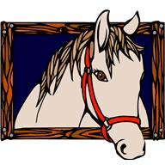
COST: $125.00 per session
Session 1 Session 2
June 14,15,16 July 19,20,21

Campers need to come with sunscreen applied, wearing barn/riding clothes (pants, shoes with a heel, a bike or riding helmet), bring a swimsuit, towel and lunch.

Limited Space available

HORSE CAMP @ JUBLIANT FIELDS
8:30 am – 3:00 pm

COST: $125.00 per session
Session 1 Session 2
June 14,15,16 July 19,20,21

Campers need to come with sunscreen applied, wearing barn/riding clothes (pants, shoes with a heel, a bike or riding helmet), bring a swimsuit, towel and lunch.

Limited Space available

