**THE 2ND ANNUAL   
 *“OPEN HOUSE IN THE GARDEN”***

July 13TH  
 5PM - 7PM

**Wednesday  
 July 13th, 2016  
 5pm-7pm  
 (Rain date July 14th)**

*at the*  
 **FOREMAN HOUSE   
 COMMUNITY   
 DEMONSTRATION/LEARNING   
 GARDEN\***

**HOSTED BY THE**

***EXTENSION MASTER GARDENER VOUNTEERS OF PASQUOTANK COUNTY***

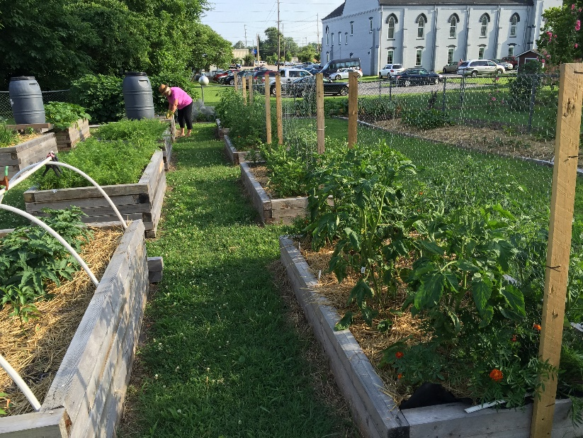

* **DEMONSTRATIONS**
* **GARDEN FOOD SAMPLINGS**
* **ASK A MASTER GARDENER**
* **CHILDREN’S ACTIVITIES**

**Come visit our wonderful learning   
 garden located right here in   
 Elizabeth City!**

**FREE**

**\*Directly behind the Foreman   
 House Bed and Breakfast at 311 W   
 Church St. off of Culpepper St.**

