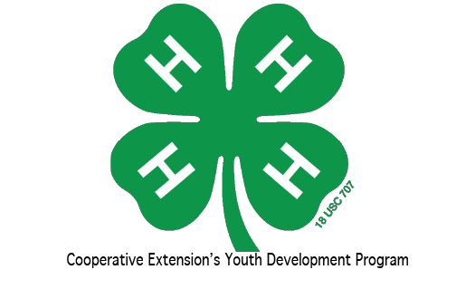

**Keli Boone, 4-H Agent**

**252-357-1400**

[**keli_boone@ncsu.edu**](mailto:keli_boone@ncsu.edu)

[**https://gates.ces.ncsu.edu**](https://gaes.ces.ncsu.edu)

**Facebook: Gates County 4-H**

**Arts & Crafts**

**4-H Club**

**Who:**  K- 5th graders

**What: Arts & Crafts Interest Club meeting**

**When:** February 18, 2016

6:00 pm

**Where:** Gates County Community Center

Youth will learn life skills and leadership development

while completing fun and interesting arts and

crafts project each month.

Please contact Kristi Groves at [252-370-3583](tel:252-370-3583) (text or call)  for more details.

