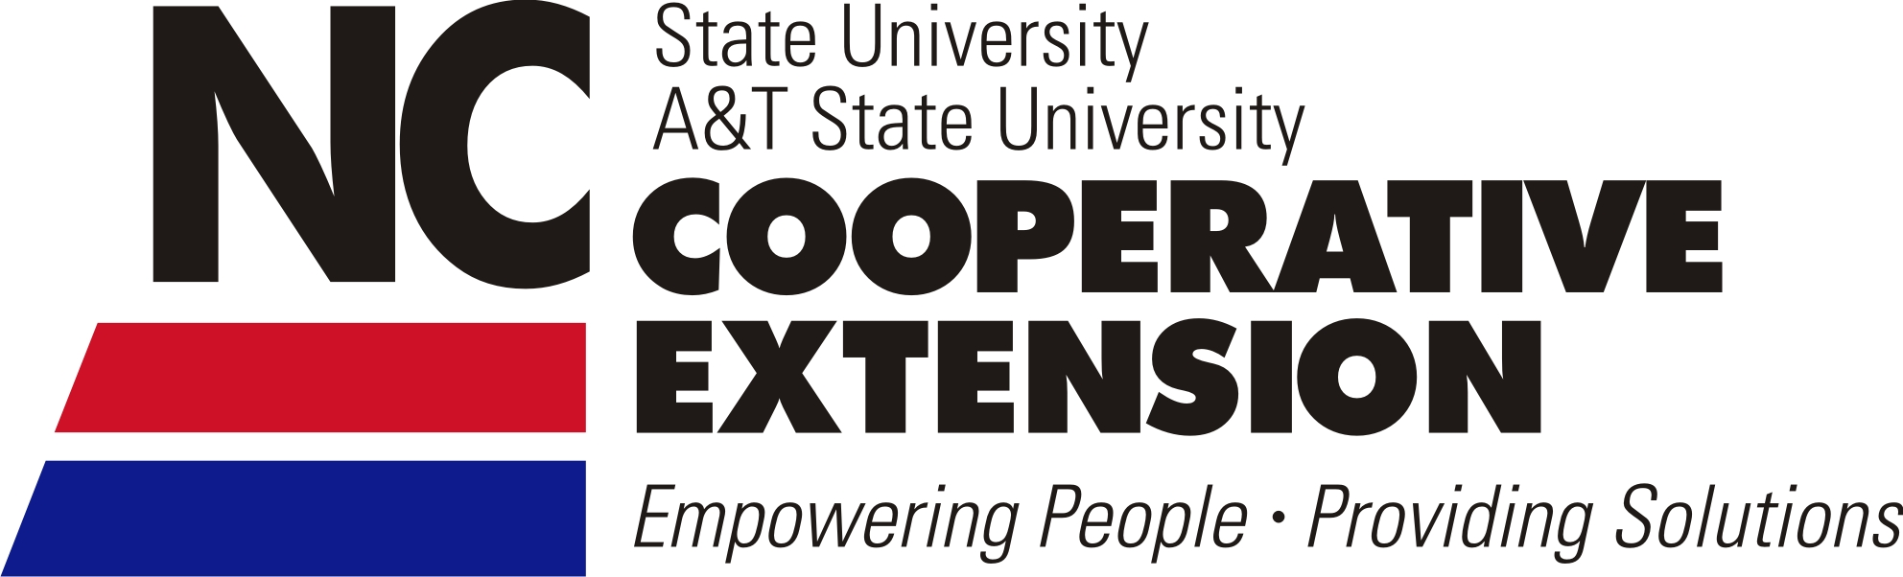
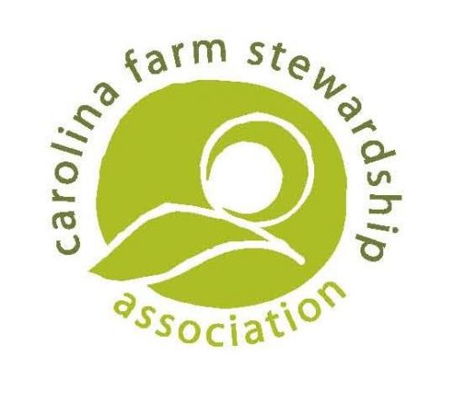
Fresh Produce Good Agricultural Practices Workshop Series

North Carolina State University and North Carolina Cooperative Extension are partnering with the Carolina Farm Stewardship Association (CFSA) to deliver workshops across the state with the aim of providing farmers with the tools to reduce food safety risks and meet market requirements.

This two-part Good Agricultural Practices (GAPs) workshop series will address how farmers of all sizes can achieve USDA GAPs certification, deliver information on principles of
fresh produce safety and on-farm hazard assessment, as well as provide assistance with creating a fresh produce farm safety plan.

The first workshop, Principles of Fresh Produce Safety and Navigating the USDA GAP Audit, takes place in a farm environment and will be based on newly developed components focused on navigating a GAPs audit. This workshop will combine classroom and on-farm instruction to provide producers with the tools needed to identify potential food safety concerns as well as strategies to minimize contamination. Participants will receive a certificate of attendance that fulfills a portion of the eligibility requirements to receive up to $600 in GAPs Cost Share assistance from CFSA.

The second workshop, Fresh Produce Safety Program and Plan Development, conducted in a computer lab, will provide direct assistance to producers in completing a fresh produce safety plan. Attendees will leave this session with a well-developed working draft of their specific food safety plan, which becomes the framework for an audit, and can be used to demonstrate individual farm risk-reduction steps. Completion of the first workshop is a prerequisite and basic computer knowledge is required in order to receive the maximum benefit from this session.

Event Details - Wayne County
Principles of Fresh Produce Safety & Navigating the USDA GAP Audit
Thursday, October 3, 2013 8:00 am - 5:00 pm
Center for Environmental Farming Systems - Small Farms Unit
400 Old Smithfield Road (NC-581), Goldsboro, NC 27530
To register, contact Jessica Strickland, 919-731-1520, jessica_strickland@ncsu.edu by September 25, 2013.

Fresh Produce Safety Program and Plan Development
Thursday, October 17, 2013 9:00 am - 4:00 pm
Mount Olive College - Lois G. Britt Agribusiness Center
Raper Hall, Room 135
634 Henderson Street, Mount Olive, NC 28365
To register, contact Jessica Strickland, 919-731-1520, jessica_strickland@ncsu.edu by October 9, 2013.

Registration is $10 for the first workshop and an additional $10 for the second workshop. Lunch will be provided.

Portions of the first workshop will take place outside. Please wear comfortable walking shoes, bring a water bottle, and appropriate weather gear. The workshop will take place rain or shine.

