Carteret County … 4-H Goat Show
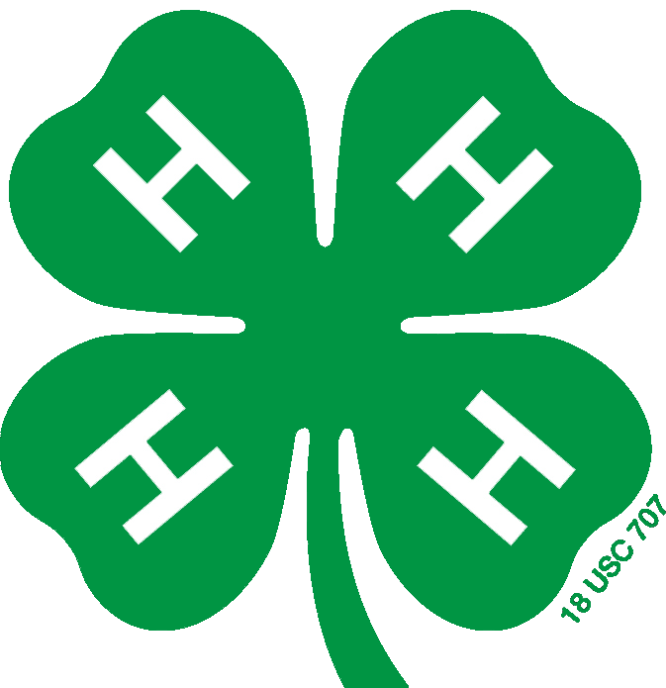

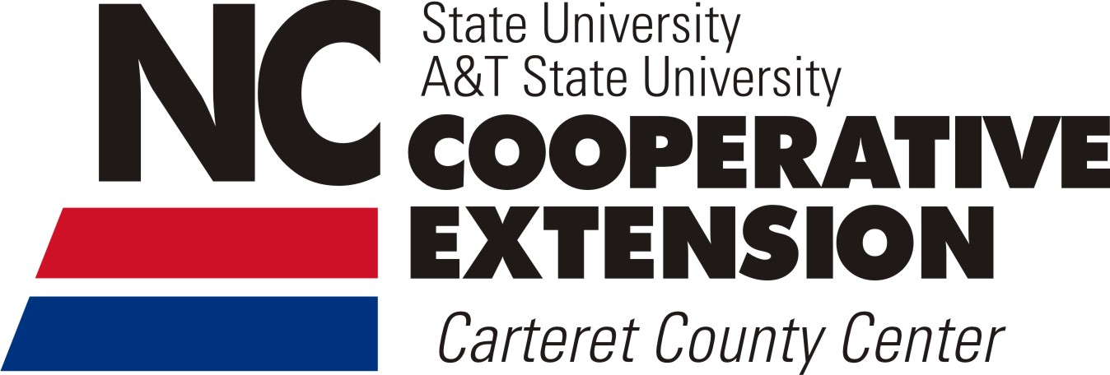

Saturday August 27nd 2016
Newport Town Park
210 Howard Boulevard Newport, NC
10:00 AM
(Show Check In 8:00-9:30)
Youth ages 19 and under are eligible to participate
Judge: John Tart III
To register contact Chris Davis:
(252)241-6731
007cdavis@gmail.com
This show is put on by the Carteret County Junior Livestock Committee as a part of the Eastern Carolina Meat Goat Showmanship Circuit.

Carteret County 4-H Goat Show
Saturday August 27, 2015 | Newport Town Park, 210 Howard Blvd. Newport, NC

Entries must be postmarked by Friday August, 19
Entry fee is $10 per participant
Name:_________________________________ Date of Birth:_____________
Address:_________________________________________________________
______________________________________ County:___________________
Phone Number: ______________ Email:_____________________________
Parent/Guardian Name:______________________________________
Number of goats:____(Maximum of 2)
I am participating in the costume class Y__ N__
Return Entry Forms to: Carteret County Goat Show
C/O Chris Davis
888 Crow Hill Road
Beaufort, NC 28516
Show Contact: Chris Davis
007cdavis@gmail.com (252) 241-6731
I have read and understand the rules and regulations for the 2016 Carteret County Junior Goat Show.
_________________________________ _________________
(Participant Signature) (Date)
_________________________________ _________________
(Parent/Guardian Signature if under 18) (Date)
Carteret County 4-H Goat Show Rules and Regulations 2016
- This show is held as a part of the Eastern Carolina Goat Showmanship Circuit and will follow all rules in accordance with the circuit.
- Animals used in competition must be entered in the name of the exhibitor.
- Exhibitors are limited to 2 entries each.
- All goats must be does or wethers. No bucks will be allowed on the premises.
- Goats must have all of their baby teeth on the day of the show.
- All goats must meet NC health requirements.
- The show committee reserves the right to refuse any animal to show due to health or age reasons.
- The show committee may ask any person acting in an unsportsmanlike manner to leave the show.
- Any exhibitor, parent or the like caught cheating will be disqualified and banned from all future shows.

- All decisions made by the judge are final.

- Any questions not covered in these regulations will be ruled upon by the show committee.

Show Information

Physical Address of Show:
Newport Town Park
210 Howard Blvd. Newport NC
Directions to the Show:
From Jacksonville: Travel highway 24 east to Hibbs Road. Turn left onto Hibbs Road. At the red light (HWY 70), turn left. Travel approximately 2 miles to the second light on highway 70 which will be Howard Blvd. Bojangles and Food Lion will be on your left. Turn right onto Howard Blvd. Travel approximately ½ mile. The Newport Town Park is on the left side of the road just past the ball field. The parking area will be behind the pavilion. Follow the signs for directions to the exhibitor area.
From Kinston: Travel east on highway 70. Drive through Havelock and travel to Newport until the first red light (Howard Blvd). Bojangles and Food Lion will be on your right. Turn left onto Howard Blvd. Travel approximately ½ mile. The Newport Town Park is on the left side of the road just past the ball field. The parking area will be behind the pavilion. Follow the signs for directions to the exhibitor area.

Show Day Contact Information:
Chris Davis (252) 241-6731
Abbi Davis (252) 241-4549
Hannah Davis (252) 241-4342

