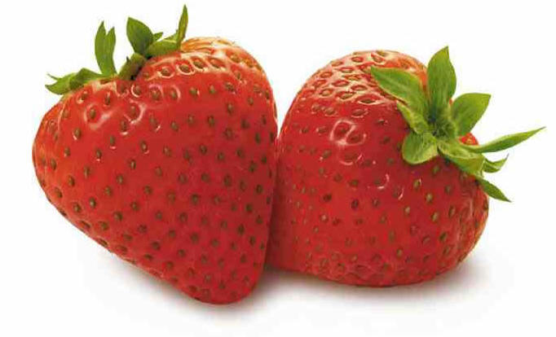

When: Friday, May 6th

Where: Franklin County Farmers’ Market

(Shelter located near Just Save)

Time: 10:30 AM-Until

(10:30 AM all recipe entries are due,

11:00 AM-judging begins)

Kick off spring at the Annual Strawberry Festival with a sweet treat of FREE homemade strawberry ice cream at 11:00 AM!

Recipe competition for adults and youth with prizes awarded for the best tasting entry in 3 categories of cakes/pies, breads/muffins, and novelties. All recipes must contain strawberries!

If you are interested in participating in the recipe competition, please visit our website, office, or call 919-496-3344 to receive an entry form and rules. Entry forms deadline is May 4th. http://franklin.ces.ncsu.edu/

SPONSORED BY:

Franklin County Agricultural Advisory Board

Ag Carolina Farm Credit
Strickland Funeral Home

Wood Strawberries
Vollmer Farm
Toney Lumber Company

