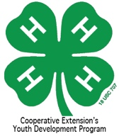
4-H Heritage Arts Entry Form

Name: _________________________________________

Age as of Jan. 1, 2016: ___________ Cloverbuds 5-8; Youth 9-12; Junior 13-15; Senior 16-18

County ______________________ Club: __________________________________________

Category Description of Craft
Basket weaving
Candle making
Crochet
Knitting
Cross stitch/needlework
Hand weaving
Jewelry Making
Natural Material Art
Pottery
Quilting
Sewing (not clothes)
Woodwork** Contestants in this category may have assistance cutting with power tools but not with design, measurements and assembly
Recycled Material Art** Contestants in this category may have assistance cutting with power tools but not with design, measurements and assembly

