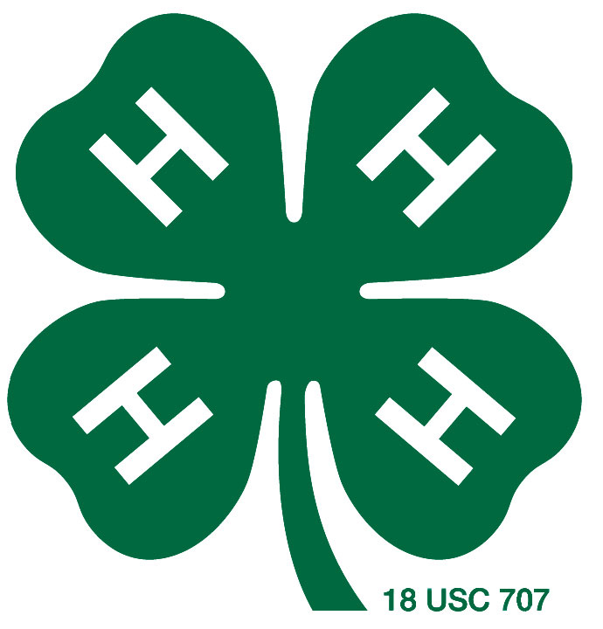

My

Cloverbud

4-H

Record Book

Cloverbud Project Record

Jones County 4-H
5 thru 8 Years Old

_______________________________
Name of Project

Name ________________________________ Date of Birth _________________ Age ___________
As of January 1 of Project Year

Address ________________________________________________________________________

________________________________________________________________________

Name of 4-H Club, After-School or Group ______________________________________________

__________________________________________
4-Hers Signature

I have reviewed this plan and agree to support its completion:

__________________________________ _________________________________
4-H Leader Parent or Helpers Signature

Dear 4-Her & Helper,
This Project Record form is designed to help a young child record and recognize their accomplishments. Any help that a child receives from a parent, volunteer, or any other adult is a very positive addition to the project and the project record form as long as the child is encouraged to do as much as possible themselves. If needed, the writing can be dictated to the helper. If more space is needed, add extra sheets of paper.

4-H is fun! Have a great time as a 4-H member. Good Luck!

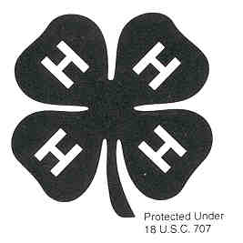
1
Things I learned and did in my project:

Examples:
Foods Project – Learned to measure dry ingredients
Outdoors Project – Went on a nature hike and saw two snakes
Bicycle Safety – Learned proper bicycle hand signals

2

Begin by introducing yourself. Tell about your experiences with your project. Add any other information you would like to include in your 4-H story. If you need additional space, you may add pages or write on the back of this page.
MY 4-H STORY

My Name is ________________________________________________________________________________

My favorite part of this 4-H Project was ______________________________________________________

The hardest part about my 4-H Project was ______________________________________________

Other 4-H activities that I enjoyed were _________________________________________________

Did other people help you with your project? If yes, how did they help? ______________________

___________________________________________________________________________________

___________________________________________________________________________________

___________________________________________________________________________________

3
Draw a picture, cut pictures out of magazines or newspaper, or attach a photograph (or copy) that shows something you did in your project. This is your mini-scrapbook. If you would like, you may add 3 additional pages of items that show how much you have done in 4-H this year.

4

