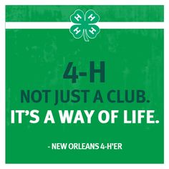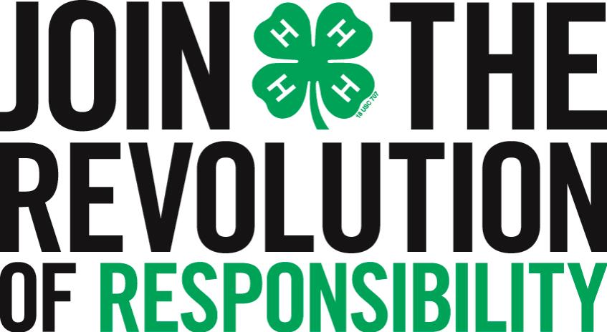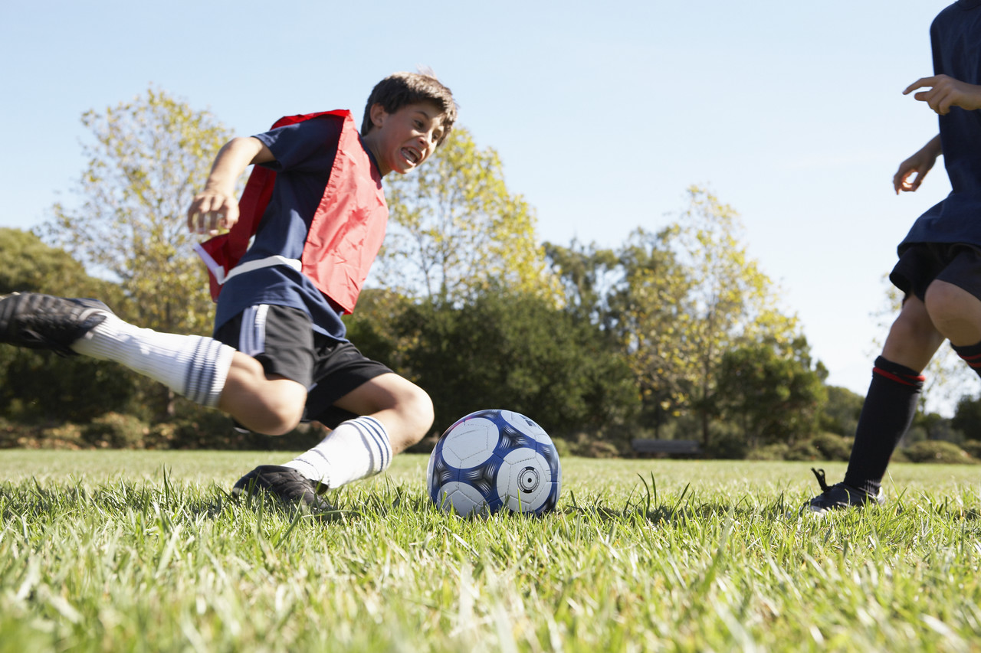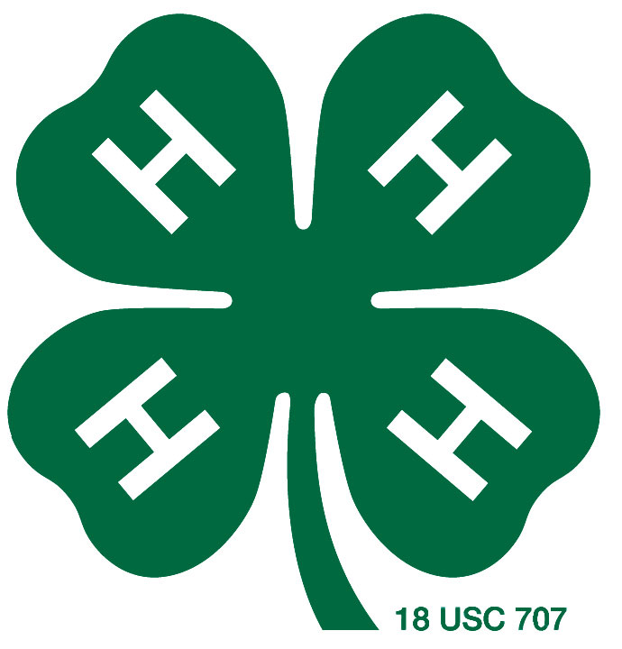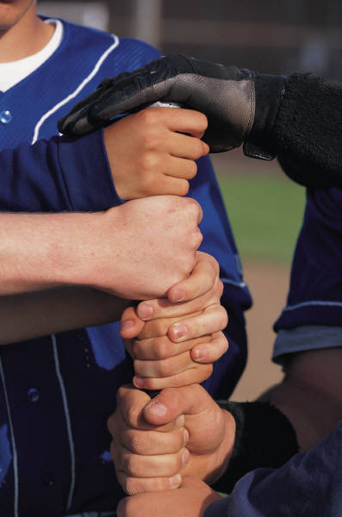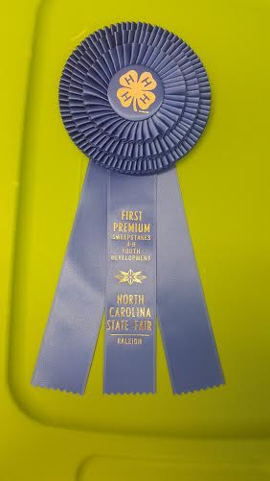

Good habits formed in youth can make all the difference in the world.

###### More inside!

During the 2015 North Carolina State Fair, we had many, many 4-Hers enter different things into the fair. From photographs, to rabbits, and sculptures to livestock, Granville county 4-Hers really took the fair by storm. There are numerous opportunities for youth to compete in different events at the North Carolina State Fair and we had a contestant in every one. One part of the fair was the Hay Bale Decorating Contest. A group of adult volunteers and their club members put together a hen and her chicks as our hay bale design. There were 13 bales entered and we received 5th place.

**Pg. 3**

Aristotle:

November/December 2015

## Granville County was HIGHLY regarded during this year’s NC State Fair

# Another Fair has come and gone…

Clover Column

Lorem ipsum dolor sit amet, consectetuer adipiscing elit. Nulla lectus mi, sodales ac, consectetuer sed, luctus sit amet, risus. Mauris tempus quam sit amet mi. Mauris sagittis augue nec augue. Fusce ipsum.

Granville County 4-H

**The annual Granville County 4-H Achievement Night has been scheduled for January 28th 6:00PM at the Granville County Expo Center in Oxford. Here we will recognize many youth and volunteers for their accomplishments this year as well as enjoy a youth talent show and a yummy dinner. We will also award the Club of the year Award. The county council nominees will give their speeches and have their campaign booths set up as well. This event is a time of celebration and excitement for Granville County 4-H so make sure you RSVP by January 15th so you don’t miss out on an amazing night! See you there!**

4-H Achievement Night

4-H Cookie Exchange

**Granville county 4-H Cookie Exchange and Holiday Can Food Drive will take place on Tuesday, December 8th at 6:00PM at the Granville County Extension Office. Please bring cookies or other small baked goods you would like to share with 4-H friends. Also, please bring as many can foods as you can so we can donate them to a local Granville County Charity for the holiday season to serve our community in a positive way. Please RSVP for this event by December 1st in order to save your spot for the event. Let us see who can bring in the most can foods! There may be a prize… you never know!**

As a 4-H agent, I rely constantly on strong, passionate, caring volunteers to help reach the maximum amount of youth in Granville county. However this is a common thread throughout the entire state of North Carolina and 4-H. 4-H could not make the impacts it does without the constant line of support from our volunteers. Volunteering is a common trend among many North Carolinians. 26.6% of state citizens reported to have completed volunteer hours in 2013. This ranks North Carolina as the 28th state in volunteering. 4-H volunteers account for many of those volunteers reported in North Carolina.

Volunteers also offer more than just their time, but their knowledge, skillsets, and passions. All 4-H volunteers have a background in something, whether it is arts and crafts, or electricity or gun safety, every volunteer brings something new and exciting that they can teach our 4-H youth. This is why I think volunteers are so special and crucial to our organization.

I also believe that volunteers can learn a lot themselves from serving our organization. Many times, volunteers come up to me talking about something a child has taught them just by being with them for a few hours. It is truly an amazing experience for adults and youth alike to volunteer their time, experience, and knowledge to serve our organization and bring a new realm of imagination and creativity but most importantly education to the youth we serve everyday right here in Granville county, and North Carolina. For more information about volunteering with 4-H, contact Taylor Jones at (919) 603-1350.

**cont.**

And we placed 5th in that competition. I also have to congratulate every 4-Her who submitted a craft or piece of artwork. Not only did we have the most entries of any other county, we also had the most 1st, 2nd, and 3rd place pieces. This is how we won 1st place and the big blue ribbon for county sweepstakes. Congratulations again to everyone who participated. Lets try to beat our record next year with even more participants and entries. Congratulations to everyone!

I will be posting the results of our time at the State Fair in a news release to all of our local newspapers. Please be on the lookout for that article.

#### State Fair Continued…

Our officers will be voted on and the entire council will be inducted at the Annual Achievement Night. More details available online.

If you are interested in running for an officer position, please talk to Taylor about the application process. It’s easy!

Please decide on a club representative no later than December 1st. Inform Taylor on your representative soon after.

If you have any questions, call (919) 603-1350. Or email tejones5@ncsu.edu

As many of you are already aware, Granville County is in the process of creating a brand new 4-H Teen County Council. The council will be made up of a President, Vice-President, Secretary/Treasurer, and Reporter/Historian. We will also have a representative from every club in the county. This council will help the 4-H agent with programming, marketing, and public affairs. Important info below:

Teen 4-H Council



*Taylor E. Jones*

*4-H Youth Development Extension Agent*

*North Carolina Cooperative Extension*

*North Carolina State University*

*Granville County Center*

*(919) 603-1350 tejones5@ncsu.edu*

“To Make the Best Better”

4-H Youth Development