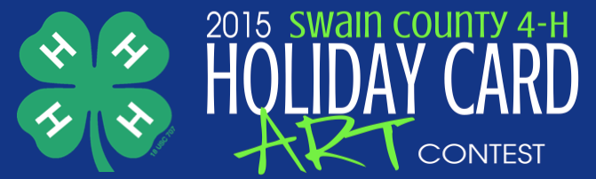

Entry Date: ____________ Artist Name: _______________________________________ Age: ______ Grade: ______
4-H Club: _________________________________ School Name: ___________________________________________________
Home Address: ________________________________ City: ___________________________ Phone: _________________
Parent/Guardian Name: _________________________________________ Relationship: __________________________
Email Address: _________________________________________________________________

- Artist must age 5 to 18 and enrolled in 4-H.
- One winner from each age category will be chosen. Ages categories: 5-8, 9-13, 14-18
- Artwork must be on a solid white sheet of unlined paper and no larger than 8 ½ x 11 and no smaller than 5 ½ x 8 ½.
- Paint, marker, pencil and crayon are all acceptable.
- Dimensional art is acceptable as long as it can be photocopied.
- Artwork must be submitted with the entry form and within the size parameters.
- Artwork must show December Holidays or a winter scene AND include an aspect of 4-H.
- All Artwork must be original work by the artist.
- By submitting art work for the contest, you and your legal guardian agree that your
name age, club and school may be used on the Holiday Card and mailed out to the public.
- All artwork submitted becomes property of the Swain County Cooperative Extension.
- We reserve the right to modify the winning artwork to fit on the Holiday Card.

Winning Artwork will be used on the 2015 Holiday Card mailed out by the
Swain County Cooperative Extension

Artwork must be received by October 23, 2015 by 5pm.
Entries must be mailed to the County Extension Office or dropped off during regular business hours at 60 Almond School Road, Bryson City.

Artist Signature: _______________________________________________________
Parent/Guardian Signature: __________________________________________________________
For more information: contact Jennifer Hill, Swain County 4-H Agent at 488-3848 or jrhill9@ncsu.edu.edu

