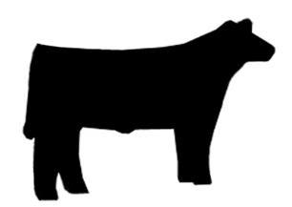

**2015 Cumberland County Fair**

**Youth Livestock Show and Sale**

**Wednesday, September 16, 2014 at 5:00pm**

**Livestock take-in between 11:00 am—4:00 pm**

***Pre-Registration closes Wednesday, August 26, 2014 at 5:00 pm***

Name __________________________________________________________________

Address __________________________________________________________________

__________________________________________________________________

County __________________________________________________________________

Phone __________________________________________________________________

Date of Birth ______________________ Age ______________________

**______ I would like to participate in the Little “Ewe” Jump Start Livestock Clinic**

Open to youth ages 2-4. Parental supervision will be required for participation. An animal will be provided.

Presently the swine show is **NOT** a terminal show. This status is subject to change. Please contact Liz Lahti with any questions at (910)321-6862.

**Animal Information:**

**Market Hog Show**

Number of Hogs (Limit 1 per weight class; 2 weight classes) ______

**If not raising own hog, did you attend one of the two MANDATORY Showmanship Clinics? _____yes _____no July 25, 2015_______ or August 8, 2015________**

**Feeder Calf Show**

Number of Feeder Calves (Limit 1) ______

**Steer Show**

Number of Steers (Limit 1) ______

**Showmanship Division (circle one)**

5-8 year olds Junior (9-13) Senior (14-18)

*You may either email (elizabeth_joseph@ncsu.edu), mail or fax the completed form. The Cumberland County Cooperative Extension fax number is (910) 321-6883. You may mail the form to:*

**Cumberland County Cooperative Extension**

**Attn: Liz Lahti**

**301 East Mountain Drive**

**Fayetteville, NC 28306**