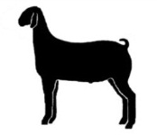
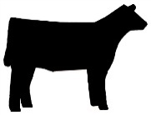
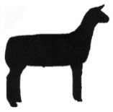

Cumberland County Fair Junior Livestock Shows

Pre-Registration closes Wednesday, August 26, 2015 at 5:00 p.m.

Market Lambs Meat Goats Beef Heifers
Tues., Sept. 15, 2015, 7:00 pm Thurs., Sept. 17, 2015, 7:00 pm Fri., Sept. 18, 2015, 7:00 pm
Weigh-in: 4:00 – 6:00 pm Weigh-in: 4:00 – 6:00 pm Check-in: 4:00 – 6:00 pm

Name __________________________________________________________________

Address __________________________________________________________________

__________________________________________________________________

County __________________________________________________________________

Phone __________________________________________________________________

Date of Birth ______________________ Age (as of Jan 1, 2015) ______________________

Animal Information:

Market Lamb Show

Number of Lambs (Limit 1 per weight class; 3 weight classes) ______

Ear Tags: ______ ______ ______

Meat Goat Show

Number of Goats (Limit 1 per weight class; 3 weight classes) ______ Ear Tags: ______ ______ ______

Beef Heifer Show

Number of Heifers ______

Breed ________________ DOB ___________ Ear Tag/Tattoo _____

Breed ________________ DOB ___________ Ear Tag/Tattoo _____

Breed ________________ DOB ___________ Ear Tag/Tattoo _____

If additional heifers, please list on back.

Showmanship Division (circle one)

5-8 year olds Junior (9-10) Intermediate (11-13) Senior (14-18)

You may either email (elizabeth_joseph@ncsu.edu), mail or fax the completed form. The Cumberland County Cooperative Extension fax number is (910) 321-6883. You may mail the form to:
Cumberland County Cooperative Extension
Attn: Liz Lahti
301 East Mountain Drive
Fayetteville, North Carolina 28306

