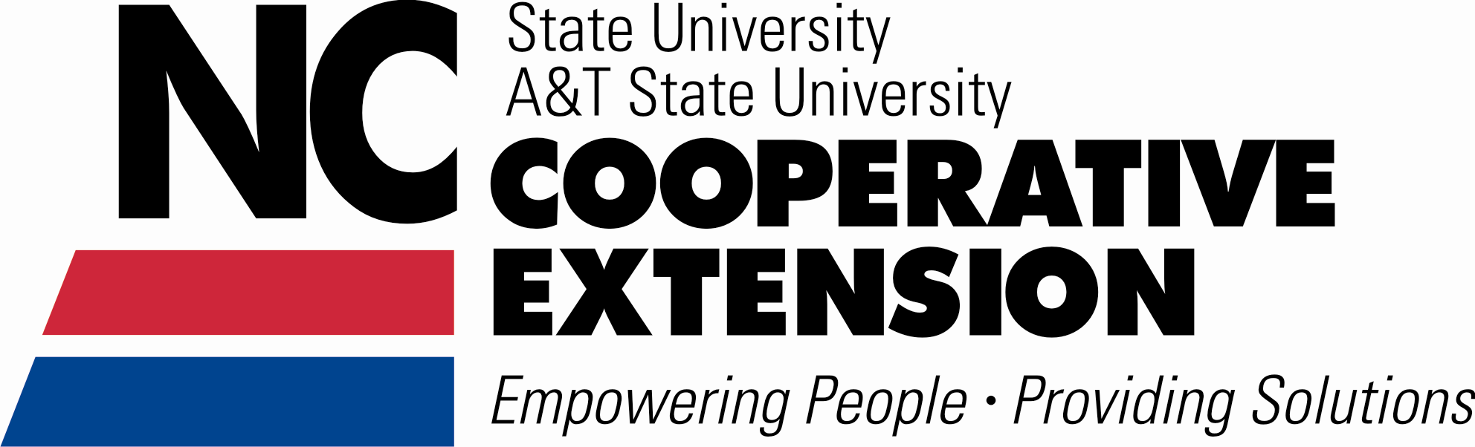






Moore County Extension
4-H Summer Adventures
Come join the FUN!
Summer
2015

June 10-15 □

MOORE COUNTY
4-H SUMMER ADVENTURES

4-H Summer Adventures is a collection of educational workshops, field trips, and hands-on activities planned especially for youth. This program is sponsored by 4-H, the youth development program of the Moore County Center of North Carolina Cooperative Extension. These activities are open to all young people ages 5-18. All ages are as of January 1, 2014. Five year olds registering for classes must have completed kindergarten. You do not have to be a 4-H member to participate, so bring your friends!

REGISTRATION
4-H is open to all youth ages 5-18. All fees are for educational supplies, admission fees, limited insurance, and transportation costs. The 4-H Enrollment Form, Registration Form, and the Medical Information and Informed Consent Form (must be notarized) must be completed in their entirety and signed by parent/legal guardian to complete registration. Registration will not be accepted if forms are incomplete. Prepayment is required to reserve a space. We cannot accept registrations by phone. Please mail your registration and money or bring to the office. Make your checks payable to NC 4-H Development Fund and use one form per child. Completed forms and payment may be sent to us at: Attn: 4-H, PO Box 1149, Carthage NC 28327.

Activities are filled on a first-come, first-serve basis. You will be notified if your activity choice has been filled. NO REFUNDS - unless class has been filled or canceled.

If your child has any special needs, contact the 4-H office prior to registration. Every effort will be made to accommodate special needs if adequate notification is given. Any additional costs incurred, such as admission fees, will need to be paid by the parent or guardian.

QUESTIONS
For more information about 4-H Summer Adventures or the 4-H Program in Moore County:
Call 910-947-3188, Monday-Friday, 8:00 a.m. to 5:00 p.m.

SPECIAL RULES
• Field trip return times can vary due to traffic and weather conditions. We will attempt to notify those picking up the children if the return time changes by more than 15 minutes.
WORKSHOP PARTICIPANTS under the age of 8 or below 80 pounds in weight will be required to provide a child safety restraint seat when attending field trips.

• NO FLIP-FLOPS, opened toed shoes, or sandals allowed for any activity! Youth will not be allowed to participate if they do not have appropriate footwear.

Field trips will be led and supervised by: Karen Smith, 4-H Program Assistant.

North Carolina State University and North Carolina A&T State University commit themselves to positive action to secure equal opportunity regardless of race, color, creed, national origin, religion, sex, age, veteran status or disability. In addition, the two Universities welcome all persons without regard to sexual orientation. North Carolina State University, North Carolina A&T State University, U.S. Department of Agriculture, and local governments cooperating.


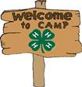
Millstone 4-H Camp
DATE: June 21 – 26, 2015 AGES: 8-12 (Traditional)
13-14 (Adventurers)
COST: $420
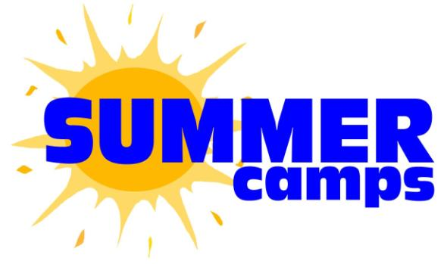
Join Moore County 4-H in Ellerbe, NC for Summer Camp at Millstone 4-H Center June 21 – 26, 2015!! Open to all youth ages 8-14. Millstone provides age appropriate, small group experiences in an enjoyable environment! Campers enjoy daily activities such as: swimming, canoeing, nature programs, shooting sports, archery, arts and crafts, hiking, campfires, and more!! The total cost is $420 for Traditional Campers (ages 8-12) and $450 for Trekkers (ages 13-14) and includes lodging, meals, camp T-shirt, and $15 store money.

GO FOR FUN, GO FOR ADVENTURE!
July 6-8
AGES 10 -15
TIME 8:00 AM – 5:00 PM
EACH DAY (tentative)
COST $100

Science and imagination join forces as campers experience the thrill of this 4 day camp. Each day will consist of non-stop adventures and projects. The fun is never ending and the excitement continues as they experience the wonderful world of science!


July 6
A&T State University, Greensboro
4-H S.T.E.M. (Science, Technology, Engineering & Math) Sciences in 4-H youth programs span from interactive forensic science problem solving activities and Junk Drawer Robotics. Teaching basic physical science concepts related robotic systems, engineering design process, and technology tools are used for learning and introducing career paths related to technology and engineering. Youth will participate in interactive science projects and learn the mechanics of programming robots. We will also learn about The Discover Agriculture program where students learn about agriculture and the environment by visiting a series of learning stations at the farm. We will finish up the day with a tour of A&T campus and meeting Cooperative Extension administrators and specialists.

July 7
Carolina Ocean Studies - Cape Fear Atlantic Voyage, Carolina Beach, NC
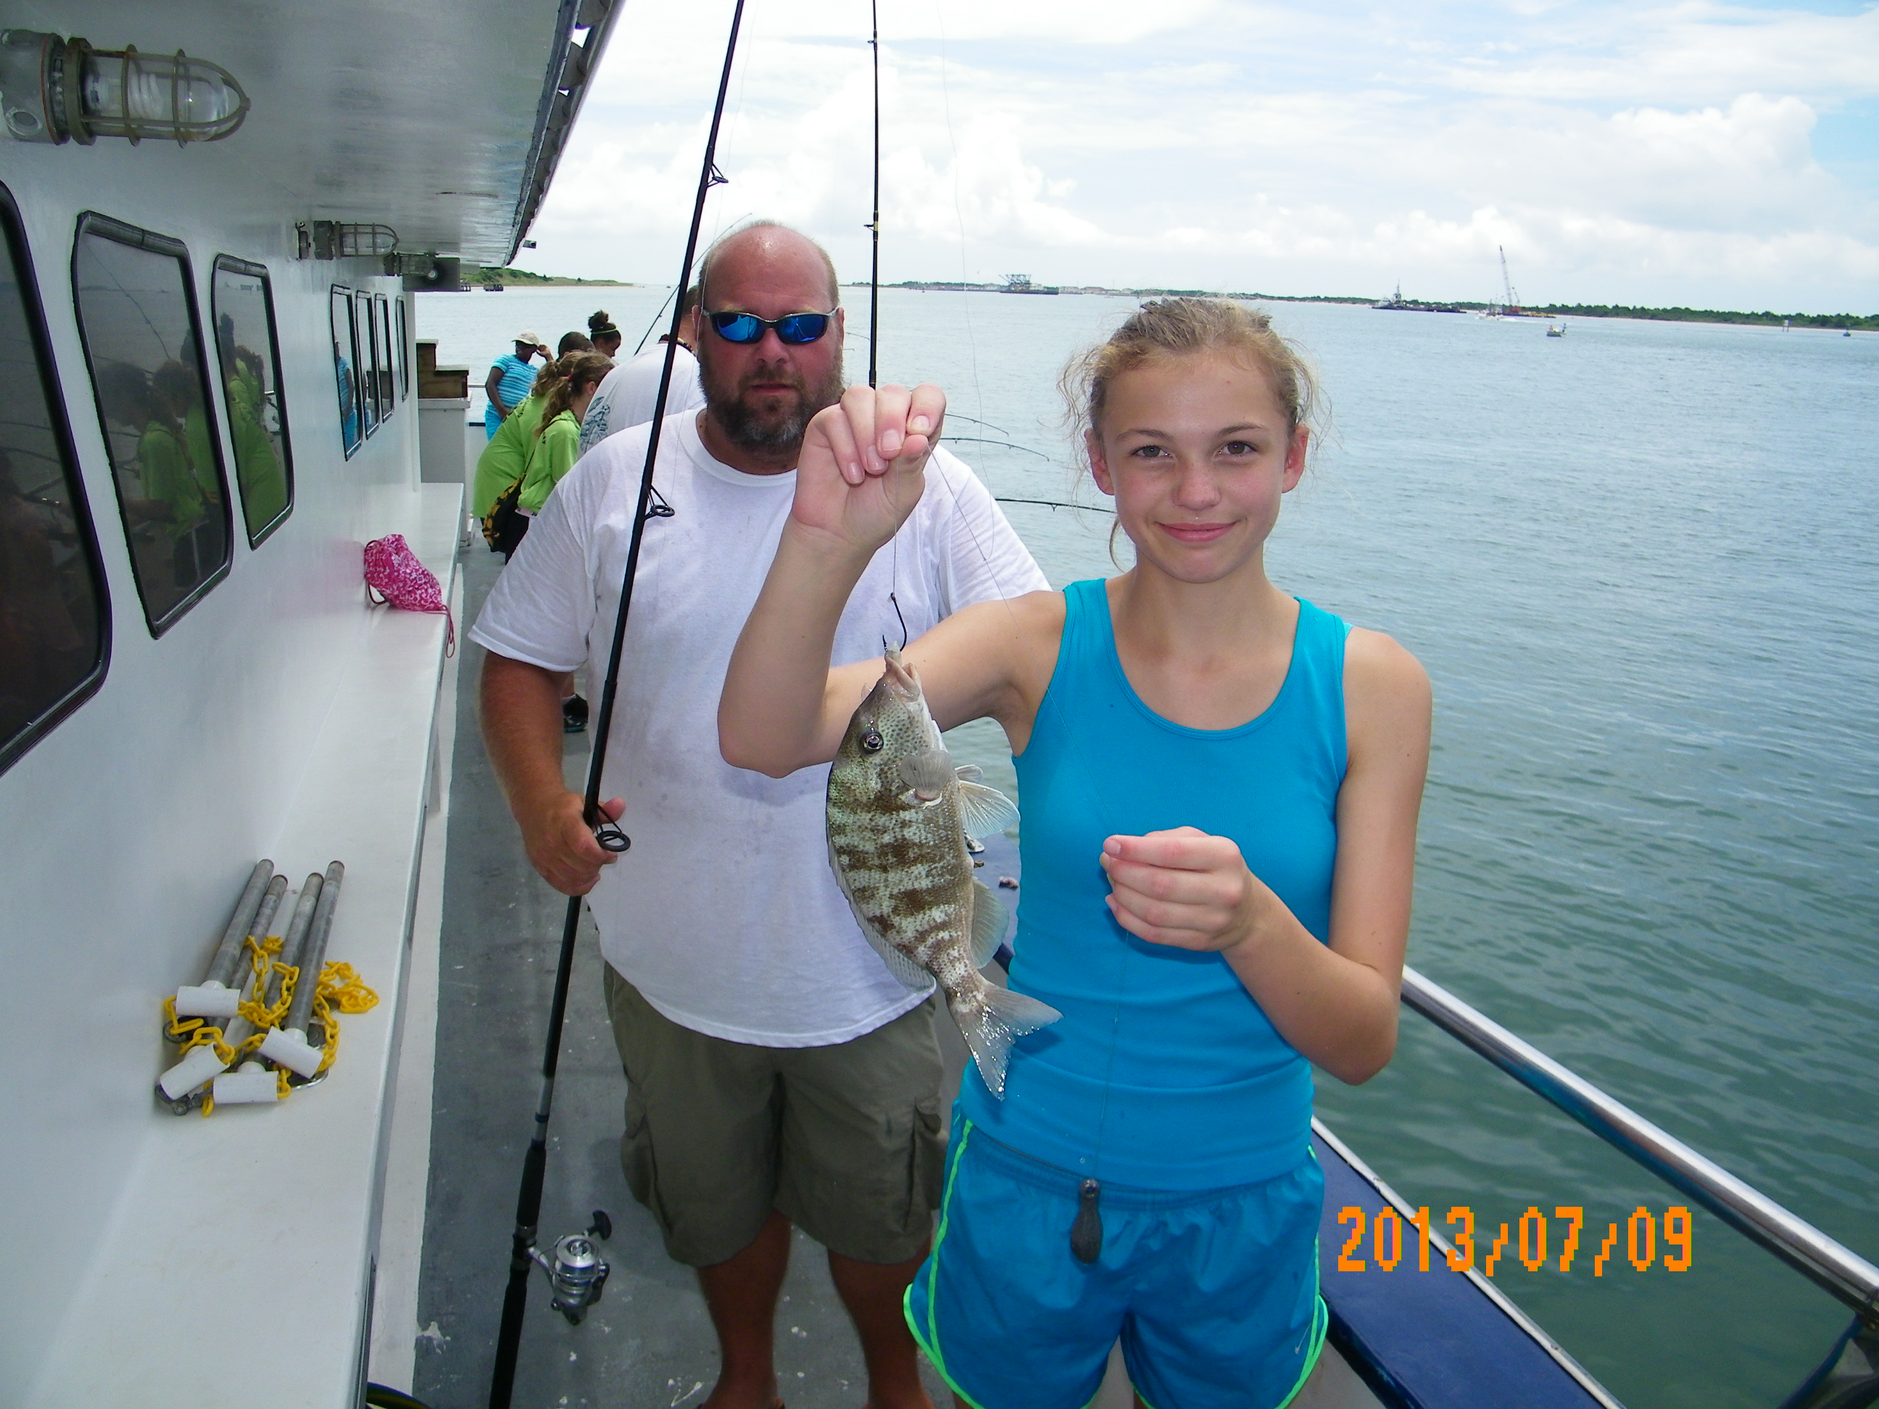
The "Cape Fear-Atlantic Voyage" is for those who want the most "at sea" experience coupled with a lot of fishing action. We will pull a shrimp net in order to collect a vast array of fish and invertebrates. The students learn about the marine life that is collected which often includes numerous species of fish, crabs, echinoderms, and sea anemones. The fish that are caught will be studied to yield insights into their adaptations and behavior. Discussion will also include the role of shipwrecks and other reefs as habitats for marine life. Bottlenose dolphins are often sighted during this trip. Other possible observations can include sea turtles, jellyfish, and sharks lurking around the boat as we fish. The exhilaration and freedom of being on the ocean is something students will always remember.
July 8
Defy Gravity Trampoline Park
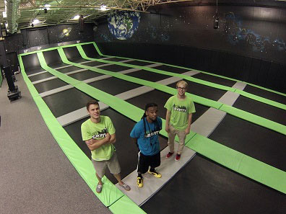
Located in Durham, this cutting-edge Trampoline Sports Arena is unlike anything you have ever experienced. Defy Gravity is a 13,000 sq. ft. facility with wall-to-wall steel-frame trampolines including the world-famous Angled Wall Trampolines, an expansive Olympic Foam Pit and one of the largest Trampoline Dodge ball cages in America. Come play, relieve stress, and turn on the adrenaline in the Triangle’s most unique and exhilarating atmosphere.

After a fun-filled morning, we will continue on our journey and tour Carolina Tiger Rescue
Carolina Tiger Rescue

Carolina Tiger Rescue provides a rich resource for the non-invasive study of wildcats, binturongs, and kinkajous, offering unique possibilities to the study of conservation techniques. Carolina Tiger Rescue specializes in wildcats and has a larger population of each species: all eating a natural diet in a low stress environment. Our tour will take us on a guided half-mile walk outdoors on grass and gravel to meet some of the world's most endangered species. Our guide will personally introduce us to tigers, lions, bobcats, servals, ocelots, and more, explaining the rescue stories that brought them to Carolina Tiger Rescue and the issues that their kind face in the wild.

The mission of Carolina Tiger Rescue includes saving and protecting wildcats in captivity.

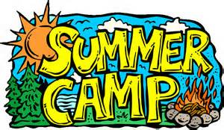
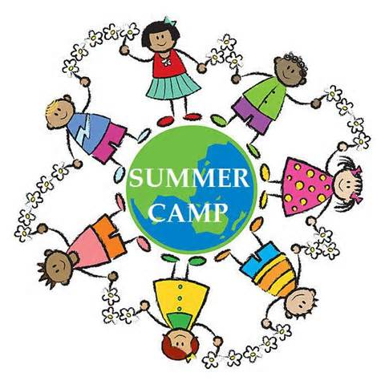
4-H DAY CAMP
Millstone 4-H Center
(Transportation provided)
DATES: July 13-17
AGES: 8-15
TIME: 8:00 am – 5:00pm
COST: $100
Day Camp is an option for local youth to experience the fun of camp activities Monday thru Friday, while spending each evening and weekend at home. Campers spend their day enjoying many of the same activities as their resident camp counterparts. Rotating from activity to activity, classes include (but may not be limited to) archery, canoeing, nature, crafts, swimming and explore their natural surrounds. Older campers also participate in team challenges and high ropes elements. A nutritious lunch and snack is provided each day.

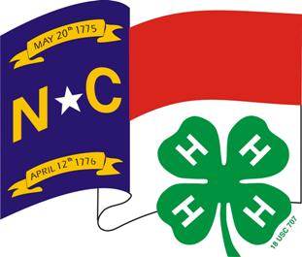
NC 4-H Congress, NC State University, Raleigh, NC
DATES: June 18 – 21
AGES: 13-18
TIME: 8:00 am – 5:00 pm
COST: $150

NC 4-H Congress is an annual educational event sponsored by the 4-H Youth Development Department at N.C. State University and planned by the State 4-H Council. Congress will be attended by approximately 800 youth ranging in age from 13 to 18 and representing every county in North Carolina. Participants will experience leadership workshops, recreational activities, and make friends for a lifetime.



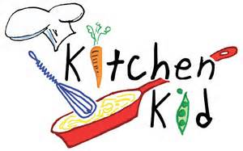
DATE: July 27
AGES: 5-8
TIME: 9:00AM – 12 Noon
COST: $5.00

Teaching your children how to cook is one of the best gifts you can give them. A cook must be creative, understand math fundamentals, science, nature, have excellent hand-eye coordination and be constantly attentive to reading and writing. Getting children involved in preparing their own meals is also a wonderful opportunity to instill the importance of eating nutritious meals. The key to a healthy lifestyle is a healthy diet—and Kids Kitchen is a fun, hands-on learning experience where kids prepare healthy and nutritious food.

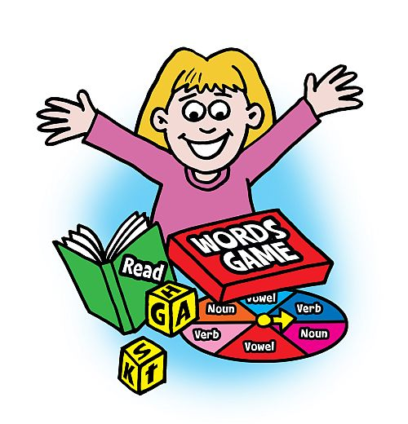
ALL FUN & GAMES
DATE: July 28
AGES: 5-8
TIME: 9:00am – 12 Noon
COST: $5.00

The lazy days of summer will find us being creative as we make crafts, play board games, be active, make butterfly snacks, ice-cream in-a-bag, and learn new science experiments. This is your day to have fun!

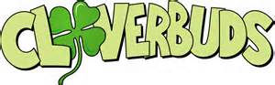
OVER NIGHTCAMP
Millstone 4-H CENTER

DATES: July 29-31
AGES: 5-8
COST: $75

Looking for the first “stay-away camp for your 5-8 year old? This is the perfect two-night, three day Camp! Smaller ratios of staff to campers provide youngsters the special attention and care they deserve. Cloverbud Campers participate in all of the “big Kid” activities including canoeing, swimming, crafts, sports & games, nature study, and fun evening activities like camp fires and s’mores. Parents may bring campers to Millstone or meet at the 4-H office at 12:30 pm to ride with 4-H Staff.

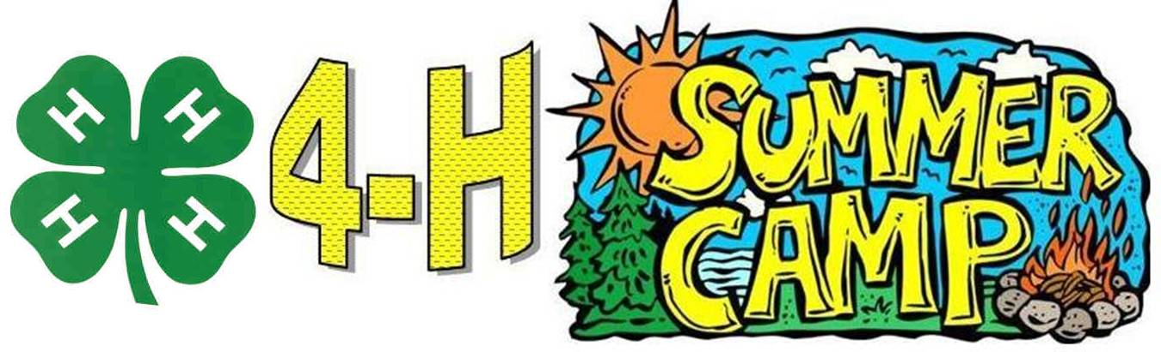





2015 Summer Fun Registration
Moore County 4-H – Co-sponsored by NC Agricultural Foundation, Inc.

Camper’s Name Age ___ D.O.B. ______

Address

Day Phone of Parent/Adult Guardian

June 21-26 □ Millstone 4-H Camp (Ages 8-12- Traditional Camp)…$420.00
□ (Ages 13-14 (Adventurers)
July 6-8 □ 4-H Science Adventures (Ages 10-15) ………….………$100.00
July 13-17 □ 4-H Day Camp @ Millstone (Ages 8-15)……..................$100.00
July 18 – 21 □ 4-H Congress @ NC State University (Ages 13 & up)....$150.00
July 27 □ Kitchen Kid (Ages: 5-8)………………………………….$ 5.00
July 28 □ All Fun & Games (Ages 5-8)….…………………………...$5.00
July 29 -31 □ Cloverbud Camp @ Millstone 4-H Center (Ages 5-8)...$100.00
July 30-Aug. 7 □ Moore County Internship Academy (Ages 14 & up)…...FREE

TOTAL………….. $_________

Camp packet will be mailed upon receipt of registration form and deposit. Please fill out one form for each child.
Make checks payable to: NC 4-H Development Fund
Mail to: Moore County 4-H
PO Box 1149
Carthage NC 28327-1149

