Why Aren’t Streams Straight?
Bill Lord
Area Agent
NC Cooperative Extension Service
In the world of streams and rivers nature abhors a straight line. Since water always flows downhill, in a perfect world streams and rivers would flow in a straight line from their point of origin to the ocean. In an effort to increase stream flows and reduce flooding we used to ‘channelize’ streams by digging them out and creating straight channels to speed the flow of water. We have also discovered that channelizing a stream may get the water off our property faster, but it creates more downstream flooding than a natural stream channel. Unless these straight channels have concrete sides installed, the streams almost always revert to curves or meanders. So why does water in a stream or river ‘wander’ from side to side rather than flow in a straight line?
One of the functions of a natural stream is to transport sediment. In undisturbed natural streams a small amount of sediment is under constant transport due to natural stream bank erosion or erosion of the channel. Sediment, either rocks or soil, causes the water in the stream channel to change course, deviating from a straight line. The deviation is called sinuosity, and looking down on a natural stream from above shows ‘S’ shaped curves that are part of the stream’s natural sinuosity. To see a striking example of sinuosity in the Tar River, take a walk in Louisburg’s Riverbend Park and walk along the river bank upstream from the old rock dam in the river. The park gets its name from the bend in the river just above the dam, and the bend is a classic case of a river’s natural sinuosity. If you watch the river in the course of time at Riverbend Park you will notice that when the river is in flood stage the water cuts through the park and bypasses the bend, seeking the path of least resistance. This is a natural geomorphic process in which the river is ‘straightening’ itself out during high flow events. When bends or meanders in a river become extreme, sometimes the river will cut them off and form what is known as ox bow lakes, as the river cuts a new channel and forms a slightly straighter path to the ocean. Over time the oxbow lakes will fill in with sediment during floods.
Another term for a bend in a river or stream is meander. A meander forms when water moving side to side in a stream erodes the stream banks. As silt is added to the stream the water spreads out and the stream widens its valley. As the water spreads out and begins to curve or meander it begins to cut away at the stream bank. This cut becomes the outside angle of a curve, and the silt cut from the bank is deposited on the inside of the curve where there is less energy, resulting in a snaking pattern. The sediment deposited in the inside of the curve or meander frequently forms as a sand bank. Many of us have walked on sand banks in the curves of rivers or creeks and noticed how the water gradually deepens as we cross the river on the sand bank until we reach the deepest part of the channel on the bank opposite the sand bank.
The deepest part of a steam’s channel is called the thalweg. The location of thalwegs matter because rivers and creeks are often used as the demarcation of property boundaries. Look at a map of the United States and notice how many state lines are defined by river courses. A discussion of thalwegs and meanders matters in everyday life because landowners can have a direct impact on the extent to which stream channels and stream banks move, which can have a direct impact on the boundaries of personal property. If stream banks are not protected and are allow to erode a person can lose property as their land washes away, or their property boundary could be constantly in motion due to unstable stream banks.
People like water, particularly running water, and if they have a stream on their property they like to be able to see it. This applies to rivers and lakes too in that waterfront property costs more and people like to be able to see the water if they pay a premium for waterfront property. The problem with exposed waterfront property is that it is prone to erosion and loss. Floods are a natural phenomenon, but as we have added impervious surfaces – roads, parking lots, and roof tops – to our environment we get more stormwater runoff and more flooding. More flooding means more pressure on stream banks and more erosion. In an effort to protect stream banks and maintain their view of the water people use hardened structures like wooden bulkheads, concrete retaining walls, and boulders and rip-rap (bowling ball sized layers of rocks). The problem with the use of hardened structures is that if water gets behind or under the hardened structure the structure will fail as soil is washed out from under it. The best way to stabilize the shoreline of a stream, river, or lake is with natural vegetation. Trees and shrubs have deep root systems that hold stream banks in place and if a tree falls in a stream during a flood new trees and shrubs will fill in the gap as seedlings germinate in the space vacated by the fallen tree.

Stream in Wilson County that has been dug out and channelized. Note the stream is reverting to natural meanders in the bottom of the channel.
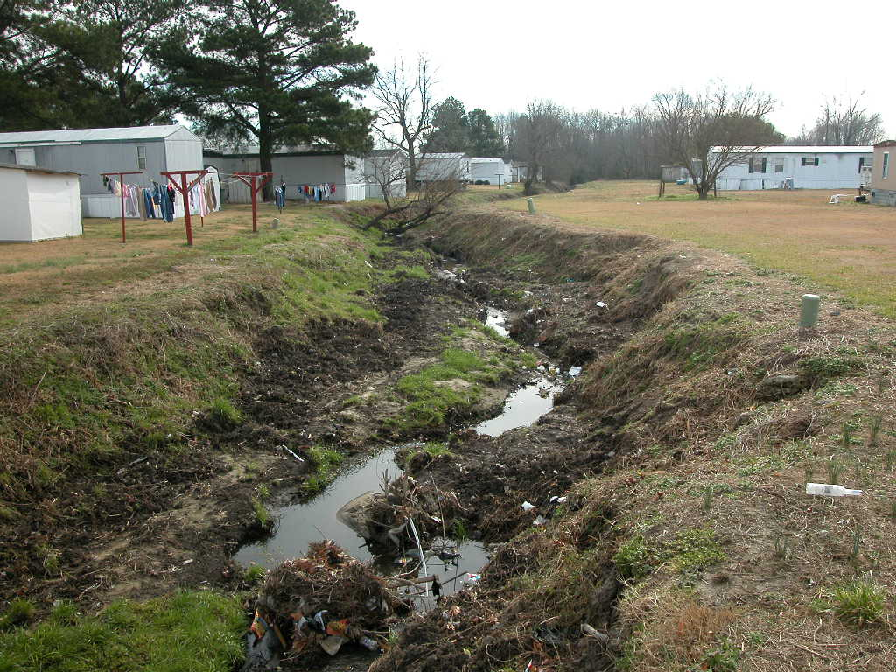

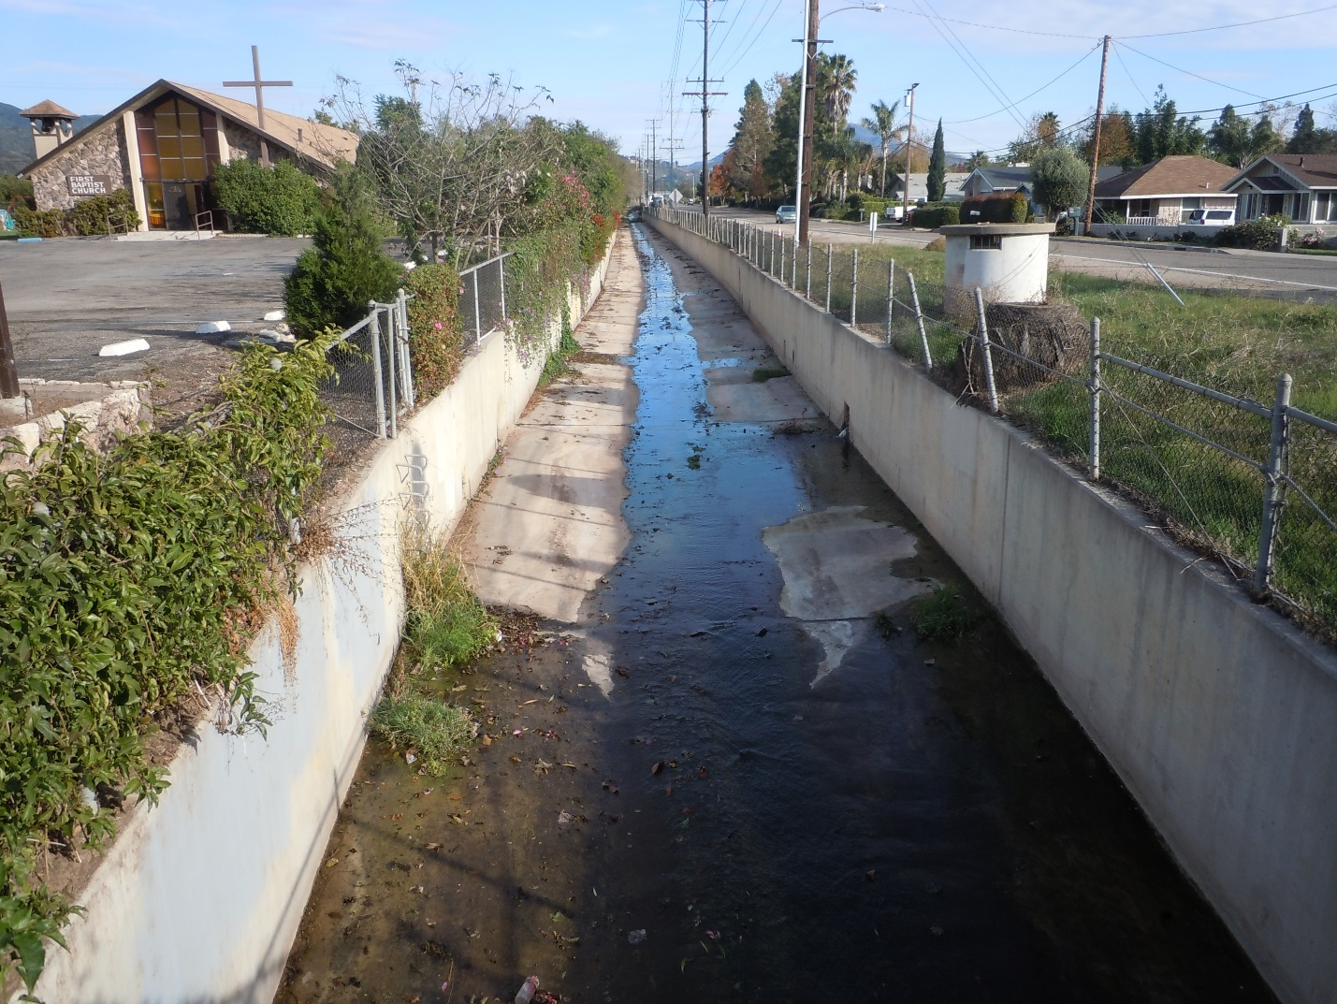
Channelized stream in Eastern North Carolina. This stream in biologically dead and while it drains rapidly it will make downstream flooding worse by delivering more water than a natural meandering stream with functioning flood plains

