Announcing the

DAVIE COUNTY EXTENSION MASTER GARDENER
FALL GARDEN SERIES PROGRAM
SCHEDULE FOR FALL 2014

PROGRAM TOPIC | LOCATION | DATE | TIME
WRAPPING UP THIS GROWING SEASON AND PREPPING FOR THE NEXT | FARMINGTON COMMUNITY CENTER,  Mocksville | September 16 | 1:30-2:30PM
 | DAVIE COUNTY LIBRARY, Mocksville | September 16 | 6:30-7:30PM
ATTRACTING and CARING FOR BACKYARD BIRDS IN WINTER | COOLEEMEE, First Baptist Church | October 14 | 1:30-2:30PM
 | KINDERTON CLUBHOUSE, Advance | October 16 | 6:30-7:30PM

Programs are free of charge but registration is required as space and handouts are limited. To register, please contact Pam Jones at pam_jones@ncsu.edu or Karen Robertson at karen_robertson@ncsu.edu or by calling 336.753.6100.

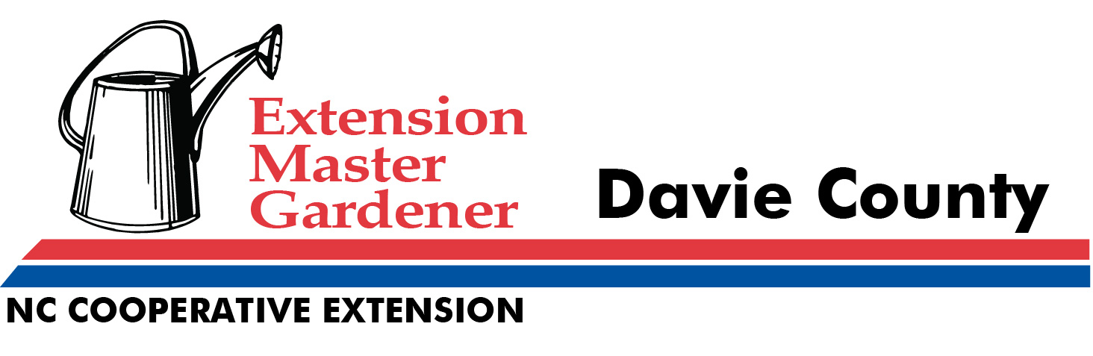

Wrapping Up This Growing Season – First time vegetable gardener or old pro? “Just give me my flowers and trees and I’m fine” more your style? Whatever your gardening experience or preference, you will take away information that will improve your gardening skills for next growing season.

Attracting and Caring for Backyard Birds in Winter – Who doesn’t need a splash of color flying by the window on a dreary day? Learn how to prepare and stock feeding stations to attract a variety of birds. Get out the garden catalogs to plan how to plant your yard to maximize bird habitat. Join fellow birding enthusiasts of all levels of experience for this colorful, fun program.

