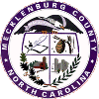 | Mecklenburg County 4-H Club Charter Request Form  New Club  Renewing | 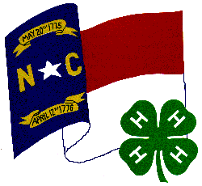

4-H Club Name:

4-H Club Leader:
(List lead contact here. Attach additional names, addresses, phone and email.)
Contact Address:

Contact Phone: Email (if available):

Day and time of club meetings:

Location where club meets:

Officers: President

Vice-President

Secretary/Treasurer

Reporter

- Please attach club roster and/or completed enrollment forms. (Must have at least five 4-H members to be considered a chartered 4-H Club in North Carolina.)
- Please attach a club program plan for at least six meetings. (Minimum of meeting dates and locations)
Signature of 4-H Club Leader (s)

Date:
Note: Charters and seals are recognized annually within the County 4-H Achievement Program.
4-H Department Use:
Date Received: Date Awarded:

Signature of Mecklenburg County 4-H Professional Date Approved

Please return to the Mecklenburg County 4-H Office, (704) 336-2082 FAX, (704) 336-6876
 | Mecklenburg County Cooperative Extension  1418 Armory Drive  Charlotte, NC 28204

