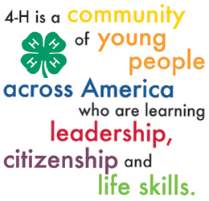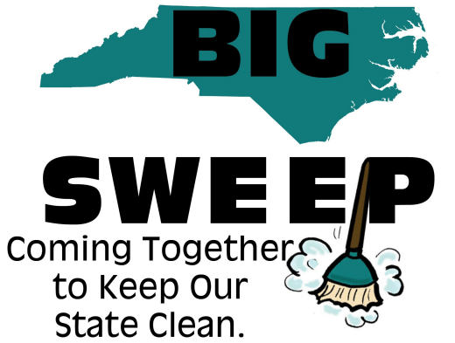

**Application to Participate in Greene County 4-H Sponsored 2014**

**Big Sweep Event**

Instructions: Review the Zone Captain’s Instructions information to become familiar with the duties expected during this clean up event. Then, below complete the information and return to Emily Hardy by Monday, September 29th in person to 229 Kingold Blvd Suite E Snow Hill or by email at emily_hardy@ncsu.edu.

**Name of ‘Zone Captain’ (must be an adult)-_________________________________**

(This is the person in charge at clean up site during the event. Responsible for coordinating club/group volunteers and for ensuring cleanup is successful.)

**Phone number- _______________________ Email- __________________________**

(A cell phone number to be reached during the event) (Used for correspondence before event)

**Name of group/club- ___________________________________________________**

(Boy Scout, FFA Chapter, Church Group, Rotary, etc.)

**Number of expected volunteers- _____________ Age ranges- _________________**

(Needed for approximate numbers of materials)

**Anticipated location to clean- ____________________________________________**

(Parks, boat ramp (except Snow Hill boat ramp), creeks, school yards, long sides of NON-MAIN highways, etc)

**Date of cleanup- ______________________ Times- __________________________**

(Does not have to be Saturday, October 4th; can be before) (Times based on age and ability of volunteers.)

The main site will be at the Wildlife Boat Ramp in Snow Hill and will also be the site where volunteers will have to dispose of their trash on Saturday, October 4, 2014.

Contact Emily Hardy, Greene County 4-H Agent with any questions regarding this event. We hope to pick up even more trash this year with your groups help! See ncbigsweep.org for more details and information regarding this national event!

For any meeting in this newsletter, persons with disabilities and persons with limited English proficiency may request accommodations to participate by contacting Emily Herring at 747-5831, email, fax or in person at least (7) days prior to the event.

Distributed in furtherance of the acts of Congress of May 8 and June 30, 1914. North Carolina State University and North Carolina A&T State Uni­versity commit themselves to positive action to secure equal opportunity regardless of race, color, creed, na­tional origin, religion, sex, age, veteran status or disability. In addition, the two Universities welcome all persons without regard to sexual orientation. North Carolina State University, North Carolina A&T State University, U.S. Department of Agriculture, and local governments cooperating.