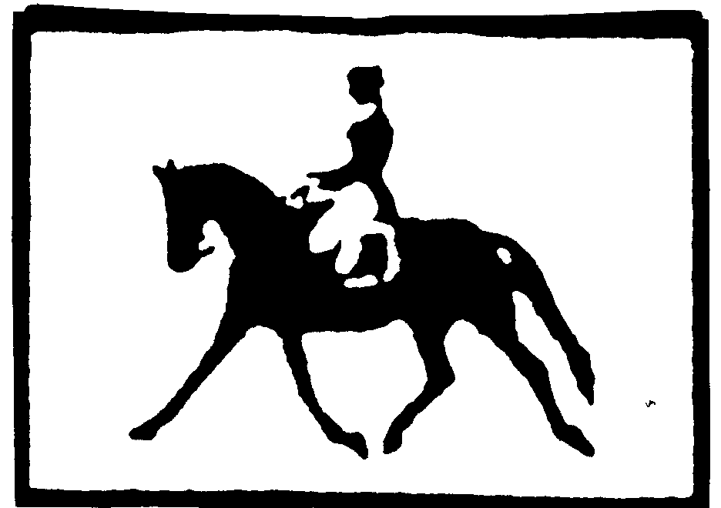
2014 STATE 4-H HORSE SHOW DRESSAGE MANUAL RULE SUPPLEMENT

Copies of the tests have been sent to each District Chairperson and should be made available at the district shows. Additional copies
of all the tests can be requested by contacting Robin Lynn at the following email address:
Robin_lynn@ncsu.edu or Mary Hunt at Kate50hunt@yahoo.com

All Dressage exhibitors are encouraged to visit the following link on t he USEF website for standards in legal tack and attire for the Dressage
Division. http://www.usef.org/documents/FormsPubs/DressageEquipmentBooklet.pdf

Four-H members participating in Dressage Division classes at the State 4-H Horse Show are encouraged to be familiar with the following rule changes and procedures, before arriving at the State Show. All rule changes and procedures were proposed by the State 4-H Horse Advisory Board and will be enforced at the 2014 State Show. Dressage participation at the state 4 -H horse show is invitational, however, in order to participate in a combined test at the state show, each exhibitor must jump a complete course of eight fences at their respective district show (placing is not a requirement).

A. CHECK IN PROCEDURES:
1. All entries must be accompanied with the following items to be accepted by show management. All incomplete entries will be returned to sender:
- Copy of notorized Medical Release Form (2 pp.) for current year which is on file with your county agent
- Copy of Current 12 Month negative Coggins (Current through last day of show)
- Copy of Current 4-H Eligibility Card on every horse entered (for each horse / exhibitor combination)

This event or activity is operating under the 4-H Code of Conduct and Disciplinary Procedure. You can obtain a copy from your 4-H Agent. This 4-H Code of Conduct and Disciplinary Procedure is a condition of participation in any North Carolina 4-H activities or programs.

Entries are to be mailed to the State 4 -H Horse Program Office (See Dressage Entry Form).

Please note: Dressage Classes entered on the General State 4 -H Horse Show Entry Form will not be accepted.

2. Familiarize yourself with your ride time(s) and plan your daily schedule accordingly. Ring assignments and ride times will be posted at the Show Office. No ride times will be given out in advance. Exhibitors are encouraged to check the posted ride schedules for updates and/or time changes.

3. Pick up your entry packet at the show office after following appropriate check-in procedures listed in the Operating Procedures handout included in the state show qualifying packet or may be found on the Extension Horse Husbandry Website: http://www/cals.ncsu.edu/an_sci/extension/horse/hhmain.html

4. Familiarize yourself with the dressage and stadium jumping arenas as to location, entry gates and exits.

5. The stadium jumping course will be open to be walked prior to the start of those respective classes held on Friday afternoon. NO HORSES ALLOWED.

6. You must check in with the Dressage Steward at the entry to the Dressage arena several minutes before your scheduled ride time. Failure to do so WILL start a one minute gate call and may result in disqualification.

7. If a rider misses their assigned ride time, they will be eliminated from the class. (Exception: Management problems or re-assigned time via the Dressage Chairperson).

8. Inform the Dressage Coordinator of any scratches.

9. THERE WILL BE NO SCHOOLING IN EITHER THE DRESSAGE ARENA OR THE STADIUM JUMPING ARENA!!!!

10. Your dressage test score sheets will be available at the conclusion of the dressage division classes. Exhibitors are responsible for picking up scoresheets at the show. NO score sheets will be mailed out to exhibitors.

B. USE OF WHIPS IN COMBINED TESTS:
Whips may not be carried in the Dressage phase of the combined training class. The Dressage Steward will monitor the use of whips.

C. POINTS:
Points will be awarded by the following standardized formula:
10 points for 1st place regardless of number of entries.
9 points for 2nd place regardless of number of entries.
8 points for 3rd place regardless of number of entries, etc.

D. DRESSAGE CHAMPION TIE BREAKERS:
Tie breakers will be awarded in the following priority order when determining the Dressage Champion and Reserve Champion:
a. Highest points earned in a single class - not % score. b. Highest % score.

COMBINED TRAINING TIE BREAKERS: All Stadium Jumping rounds will be timed with a stop watch for tie breakers only.
a. Highest placing in dressage test.
b. Lowest number of jumping faults. c. Highest % dressage score.

E. COMBINED TESTS INCLUDE ENTRY IN APPROPRIATE DRESSAGE TEST. You need not enter the dressage test for the combined test, it will automatically be assigned to you-- Combined tests are $30.00. Remember: In order to participate in a combined test at the state show, each exhibitor must jump a complete course of eight fences at their respective district show (placing is not a requirement).

The Dressage Division and Combined Training Division dressage tests have been separated. If you enter a combined test the associated dressage ride will only count for the Combined Test Champion. You must also enter a dressage test to count for the Dressage Champion however it will be an additional $15.00.

If you enter a Combined Test you will be entered into the following Dressage Test:

- We will use the USEA dressage tests as noted below:
- Beginner Novice Level- US Equestrian Federation 2010 Beginner Novice Eventing Test A
- Novice Level- US Equestrian Federation 2010 Novice Eventing Test B
- Training Level- US Equestrian Federation 2010 Training Eventing Test B
You MAY enter additional Dressage Tests.

F. YOU MAY ONLY CROSS ENTER UP OR DOWN ONE DIVISION,
ie, USDF Intro & Training Level Tests
Training & First Level Tests
BUT NOT
USDF Intro & First Level Tests

G. THE FOLLOWING CHAMPIONS AND RES. CHAMPIONS WILL BE AWARDED:
Dressage Champion and Reserve Champion
Combined Training Champion and Reserve Champion
USDF Intro High Score Ride Training Level High Score Ride First Level High Score Ride

H. Copies of the Dressage Tests should be made available at the District Show or from the District Show Chairpersons.

I. The use of USEF approved protection headgear is required in all Hunt Seat Division Classes and when mounted on the show grounds. This includes the Dressage Division.

J. Any outside assistance during the stadium jumping phase of the combined test will result in DISQUALIFICATION!!

K. One Southern Regional Slot will be awarded to the highest Dressage High Score Ride from either the Training or First Level
Rides (whichever ride score is the highest).

L. The number of rides in which an exhibitor can participate during an event day is to be limited to no more than three (in a 24 hour period).
Extension Horse Husbandry
4/14

