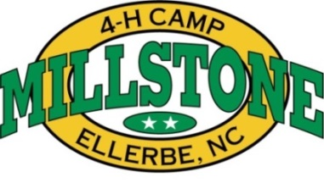

2014 Horsemanship Camp
(Please print and duplicate this form onto 8.5” x 11” paper as needed.)

The 2014 4-H Horsemanship Camp will be held on June 15-21, 2014 at Millstone 4-H Center. This rustic camp is located in Richmond County near Ellerbe.

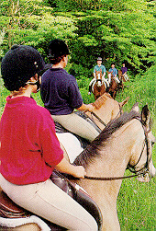
Improve your horsemanship skills while having fun with other 4-H'ers. Advanced riders can learn new and better horsemanship skills and showing techniques. A highly qualified camp staff will introduce the beginning rider to the basics of horsemanship. Special features of the camp include educational lectures, riding lessons, trail rides and training demonstrations in addition to traditional camp activities.

Instruction will be given in Huntseat and Western styles. Should enough interest exist, instruction in Games, Dressage/Eventing, Non-Trotting and/or Saddleseat will be offered. In order to ensure instruction in an additional style, 15 campers must be enrolled by April 30 of the current year. The camper must supply his/her own horse, equipment, feed, and transportation. The camp will provide sawdust for the stalls.

Attendance is open to youth 9 to 19 years of age who have access to an acceptable horse. Each camper will be solely responsible for the care and feeding of his/her mount. Each camper must have a physical examination within one year before camp and be deemed able to complete the camp activities. No horseless campers will be accepted. Camper spaces are limited and will be divided equally between Huntseat and Western riding styles. These slots will be filled on a first-come basis depending on the camper's and horse's eligibility.

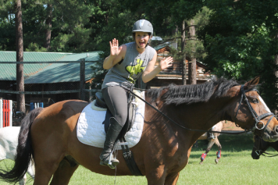
If accepted, campers must complete the horse health record with their veterinarian's assistance. This form, located in the camper's manual, states that the horse is free of disease and is in good health. Horses are required to have had a negative Coggins test for E.I.A. (Swamp Fever) dated April 1, 2014 or later. No exceptions will be made! Horses not fitting the riding program criteria or exhibiting lameness or behavior problems will be sent home.

Please direct all questions and mail completed applications to NC 4-H Horsemanship Camp, 1296 Mallard Dr, Ellerbe, NC 28338

Opportunities are available for youth leaders and adult volunteers to serve as assistants during camp. Please call the Millstone 4H Center for any questions.

Come join in a unique equine learning experience!

The North Carolina Cooperative Extension Service sponsors the NC 4-H Horsemanship Camp and is organized by the Extension Horse Specialist at North Carolina State University. This event is proudly supported by the NC 4-H Development Fund.

www.cals.ncsu.edu/an_sci/extension/horse/Webpages/NCSU_EHH_Home.html

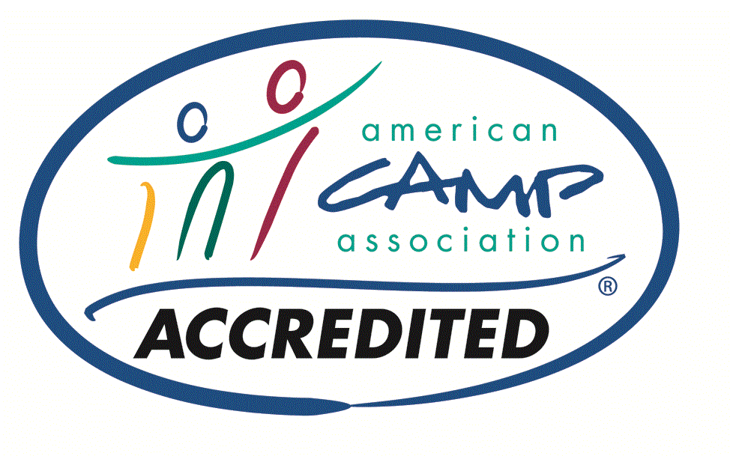
www.millstone4hcamp.com
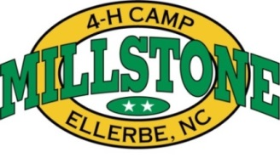
2014 4-H HORSEMANSHIP CAMP APPLICATION

OFFICE USE ONLY

Please complete this application with your parents and instructor/4-H leader’s assistance. Note: every effort will be made to provide for an equal number of youth across each riding division. No horseless campers will be accepted. Incomplete applications will not be processed and will be returned! Please type or print clearly.

1. Camper's Name
4-H Age Sex

Address

(Complete mailing address including city, state and zip code)

County
Home Phone ( )_

Parent's Name
Work Phone ( )

Email Address

2. Is your horse's health and condition suitable to complete a rigorous week of camp? Yes
No

3. | How long have you ridden the horse you are bringing to camp?
Can your horse lope/canter slow or perform simple lead changes?

Explain how well you work together:

4. Which style of riding do you intend to do at camp? (INDICATE 1st & 2nd choices).

Huntseat Western Saddleseat Games Non-Trotting Dressage Eventing

5. Have you had any previous riding instruction? Yes

If yes, please explain:

6. The horse you are bringing to camp is what:
No

Sex

Age

Breed

Name

7. Is your horse (circle correct answer): Green broke? Well broke? In training?

Explain their level of training:
8. What skills do you most want to learn or improve at while at camp (check all that apply)?

___Show Preparation ___ Trail Class Preparation ___ Management Techniques ___ Judging

___ Showmanship ___ Handling and Safety ___ Other

Explain:

9. What types of behavior problems do you have with your horse?

Biting Kicking Tying Tacking up Health Stalling

Other, please explain any other problems you have with your horse:

10. What kind of riding/training problems do you have with your horse? Please explain:

11. Would your horse be considered primarily a pasture horse or stall horse?

Please explain:

12. Have you ever attended horsemanship camp before? Yes No If yes, when?

See the N.C. 4-H Horsemanship Camp Manual for any further explanation about camp activities.

As the parent/guardian of a camper/rider who will attend the N.C. 4-H Horsemanship Camp, I do fully understand the rustic nature of the camp facilities, the liability policy under which the camp will operate, and do hereby give my consent for my child to participate in this camp under these conditions. I also understand that my equipment and horse is not insured against loss or damage. Any loss or
damage to equipment or injury to the horse or rider/camper be at my (the owner's/parent's) risk and expense.

Parent/Guardian's Signature Date _

Please send completed applications to 1296 Mallard Drive Ellerbe, NC 28338 or fax to 910/652-6905 or scan and email to keith_russell@ncsu.edu.

Once received you will be notified of your acceptance.

