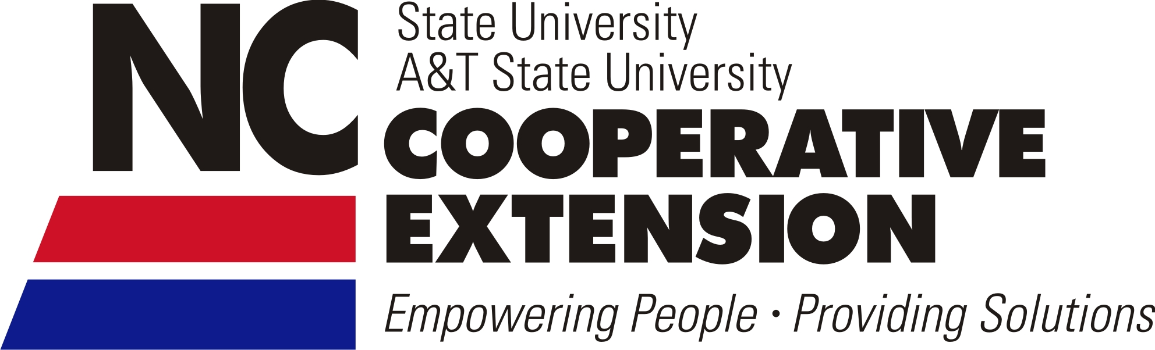
NEWS RELEASE – Month Day, YYYY
Media Contact:
INSERT NAME
EMAIL
PHONE
TITLE/ORGANIZATION

N.C. Cooperative Extension holding public listening sessions in INSERT COUNTY
RALEIGH, N.C. – As the North Carolina Cooperative Extension Service nears its centennial celebration, the organization is holding a series of 12 listening sessions across the state in November and December 2013. Cooperative Extension, which provides educational programs in 4-H, Agriculture, Family & Consumer Sciences and Community Development to citizens in all 100 counties and the Eastern Band of the Cherokee Nation, is seeking public input as the organization launches a strategic planning initiative for the future.
INSERT COUNTY NAME is hosting a listening session at the INSERT LOCATION NAME on INSERT DATE AND TIME. Dr. Joe Zublena, N.C. Cooperative Extension Service director, will be in attendance at each session to update participants on progress and to engage in discussion about the organization’s future.
“I cannot state enough the importance of this endeavor and the need for participation and feedback from the public. At Cooperative Extension’s core are people and communities, and it’s their input we need to ensure another century of educational services for the people of North Carolina,” said Zublena.
View the full list of Listening Sessions: www.ces.ncsu.edu/vision-initiative/listening-sessions
Register here: http://go.ncsu.edu/2013_ncces_listening_sessions
Cooperative Extension in North Carolina has seen recurring federal and state budget cuts of around $20 million since 2000, leaving roughly 90 positions unfilled – mostly at the county level – over the past four years. The listening sessions and strategic planning process were implemented to help the organization adapt accordingly to the economic environment and resulting impacts going forward.
Participant feedback gathered during the listening sessions will be reviewed and analyzed starting in January and will assist in the development of a recommended action plan to meet the needs of Cooperative Extension and its partners for the future.
N.C. Cooperative Extension was founded in 1914, in conjunction with the national Cooperative Extension System, as part of the Smith-Lever Act. The organization will officially turn 100 on May 8, 2014.
“North Carolina Cooperative Extension has built and maintained a high level of success over the last century,” said Zublena. “This is a journey we have to make together – employees, public and partners – and I believe that collectively we’ll navigate Cooperative Extension through this process to another century of success.”
(more)
N.C. Cooperative Extension holding public listening sessions, p.2

About the North Carolina Cooperative Extension Service
Established in 1914, the North Carolina Cooperative Extension Service (NCCES) is part of N.C. State University’s College of Agriculture and Life Sciences (CALS) and a national Cooperative Extension network. The N.C. Cooperative Extension Service partners with county and tribal governments and N.C. A&T State University’s Cooperative Extension Program to provide seamless educational programs that enrich the lives, land and economy of North Carolinians. Extension programs meet people’s needs, supply decision-makers with unbiased data and help individuals, families and communities succeed. Discover more at www.ces.ncsu.edu.
# # #

