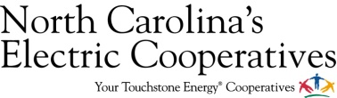
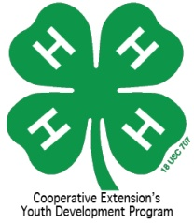
Have you ever wanted to attend an N.C. State Football game and run on the field before the players come out? If so, this is your chance! North Carolina’s Electric Cooperatives and North Carolina 4-H are teaming up to give you the chance to RUN WITH THE PACK! Twelve North Carolina 4-H youth who will be entering 4th, 5th or 6th grades this academic year and are active in the 4-H program will be chosen for this incredible opportunity! First priority will be given to youth who participate in the 4-H Electric Presentation Program and those who receive power from North Carolina’s Electric Cooperatives.
4-H’ers who are selected will run on the field prior to the October 12 NCSU Football game against Syracuse. Game time is TBD. Participants and their families will receive 4 tickets to the football game as well as 4 meal tickets! If you are interested in this opportunity, please fill out the below information. Information is due no later than Friday, August 30th. If more than 12 applications are received, a random drawing will be held to select the participants.
Name: __________________________________ County: ___________________
Address: ____________________________________________________________
Phone Number: __________________ Age: _______ T-Shirt Size (adult): _________
Parent/Guardian Names and Email: _____________________________________________________
4-H Electric Presentation Participant: Yes or No
Receive Power from North Carolina’s Electric Cooperatives: Yes or No
Please list some of your favorite 4-H activities: _____________________________
___________________________________________________________________
By the signatures below, we understand that if the above 4-H’er is selected to Run With The Pack, we are making a commitment to be at the NCSU Football game on Saturday, October 12th. Game time is TBD and will be announced about two weeks prior to the game. Youth must be at the field 1 hour before kickoff. We understand that notification will be given no later than Monday, September 9th to the 4-H’ers selected to participate.
___________________________________ ______________
4-H’ers Signature Date

___________________________________ ______________
Parent/Guardian Signature Date
Please return the above, completed application no later than 4:30pm on August 30th to:
North Carolina 4-H Youth Development
Sarah Kotzian
Extension Associate
NCSU Box 7606
Raleigh, NC 27695-7606
Or you can fax it to: (919) 515-3483

