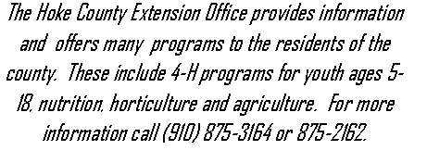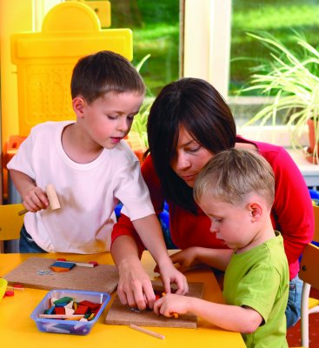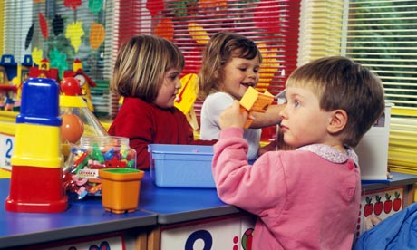

**Prepare Your Child for Pre-K**

 If possible visit the pre-school site with your child before the first day that they will be attending. Take a tour if you can so that you can show your child what the environment will look like.

Meet the teacher and assistant in your child’s classroom if they are available. Talk with the teacher and establish a pattern that will work to keep the communication process open.

Set a regular bedtime for your child. If needed begin a few weeks before the first day so that he will be in the habit of going to bed earlier. He should be rested and ready to learn when he enters the classroom.

Fine Motor Skills

* Puts a 10-12 piece puzzle together
* Holds scissors correctly
* Holds pencil or crayons properly

Gross Motor Skills

* Runs, jumps and skips
* Walks backwards
* Walks up and down stairs

Social Skills

* Uses words instead of being physical when angry
* Speaks clearly so an adult can understand him/her
* Plays with other children
* Follows simple directions
* Expresses feelings and needs
* Goes to the bathroom by him/herself
* Waits his/her turn and shares
* Talks in sentences
* Asks questions about things around him/her
* Enjoys having books read to him/her
* Can tell a story about a past event
* Says please and thank you
* Can spend extended periods of time away from mom and dad

Academic Skills

* Recognizes shapes (circle, triangle, square, rectangle)
* Sort items by color, shape and size
* Identify parts of body
* Understand concept words such as up, down, in, out, behind, over, under
* Counts from 1-10
* Recognize basic colors
* Recognizes written name
* Tries to write name

Personal Information

* Knows his/her full name
* Knows how old he/she is
* Knows address and telephone number
* Knows mother and father’s first and last name

# Getting Ready for Kindergarten Checklist

### In This Issue

Choosing Quality Childcare 2

School Readiness 2

Reading Helps Children Succeed 3

Get a Healthy Start for School 3

The ABCs of Literacy 3

Share Books With Children 4

Books for Young Children 4

Strategies to Support Language and

Literacy 4

Hands-On Learning Activities 5

Calendar of Events 6

Arts and Crafts 6

Cooking Corner 6

*Use the checklist at the left to see if your child is ready for kindergarten. Remember that these are only a few of the skills that are needed for your child’s success.*

Articles include information provided by Parents As Teachers curricula that are evidenced based.

Hoke County Cooperative Extension

Parents As Teachers

*Funded by Hoke County Partnership for Children and Families (Smart Start)*

Summer 2013

It’s that time of year when children are heading off to school and we wonder is my child ready. School readiness for a child entering kindergarten does not just begin a few weeks or months before the first day of school. The process of school readiness begins even before a child is born.

So what is school readiness? Most parents think in terms of academic skills such as number or letter recognition or counting. However, many kindergarten teachers say that a child’s social-emotional skills are more important for transitioning to school successfully. Behaviors, which allow a child to be more independent in the classroom and less disruptive, are also important. School readiness means being mentally and physically prepared to adequately function in a school or formal education setting. When children start school prepared, their chances for a smooth transition and success increases.

Day cares, pre-schools and pre-k classes prepare children for kindergarten but the parents and home environment play an even greater role in school readiness. Parents are the first, most important and most influential teacher that a child will have. A preschooler’s learning is influenced by their social interactions. Parents are in a position when they can support their child’s learning through play and everyday activities and experiences. As parents, you provide activities that promote learning. Children learn through playing with activities that interests them and allows them to get messy or make mistakes. By providing activities that are interesting and meaningful to them, the learning becomes easier and transferable to other similar situations.

Children learn through listening, observing, and interacting with the adults, children and materials in their surroundings. When parents are involved in play activities with their child, children learn best. As you are playing and interacting with them you are able to model for them appropriate behaviors. Children want to do things that they see you doing and will learn by imitating those activities and actions. By directing your child’s attention to activities and supporting their attempts at the activity, you encourage their natural curiosity and persistence. As you are watching your child play you can see what they are interested in and if the activity is too easy or difficult for them. By being a good observer and remembering that each child is different, you are able to adjust the activity to meet the developmental level of your child.

There are many ways that you can help your child be ready and successful for school. One way is to turn off the television and video games. Read to your child daily and provide them with lots of books. Talk with your child and have conversations with them about what they are doing. Play learning games such as I spy, memory, and rhyming.

Another way is to expose your child to a variety of experiences such as a visit to a museum, grocery store, library, park, zoo or post office. By including your child in everyday activities or experiences and talking with them about what they are doing increases their development and knowledge. For example, when you are grocery shopping with your child, your are able to provide lessons in literacy (reading the signs or labels), math (counting the number of canned fruits or vegetables purchased), motor (reaching, lifting and placing items in cart) social (interacting with others appropriately such as the cashier), and self-regulation (waiting to checkout).

Remember that the most important thing in getting your child ready for school is the activities and experiences that you are providing while spending time with them playing, exploring and learning about those activities and experiences. When they feel safe, valued, and loved, they feel confident in taking the lead to explore and learn.

*To find day care facilities and family child care homes in Hoke County, log on to nc division of child development and click the section for parents and look under search for child care. When you click on this to search for childcare, enter the name of the county and hit submit. All licensed day care facilities and family childcare homes will come up that are in the county. You can click on the name of the day care to get more information about the center*

Today many parents work full time and have the need to find childcare for their young children. This can be a stressful task. Often parents will have doubts that they made the right choice and feel guilty for leaving their child in someone else’s care.

Every family is unique and parents should “shop around” for quality care. There are several factors to be aware of when considering child care: cost, child’s age and needs, length of time for care, and the type of person that you want to take care of your child.

There are several childcare options. A childcare center usually has a larger number of children and more than one employee. Centers should be licensed by the state so that monitoring occurs to ensure the health and safety of the children is maintained. They may be located in schools, churches or businesses. They could be a chain childcare center or an independent center. A family day care home is located in someone’s home. These are also licensed by the state and can have no more than 5 preschool children at any one time. Other options include a babysitter or a nanny who may or may not live with the family. There are advantages and disadvantages to each option and you will have to determine what is the best option for you.

Caregivers, whether in a family day care home or a large center, should be one who responds to the child’s needs treating them with respect and affection. It is important that the caregiver and child have a positive relationship in which the secure attachment has positive influences on the emotional development of the child. The caregiver needs to be knowledgeable about child development, know how to set safe and reasonable limits, and above all love be with children.

When choosing childcare, ask the caregiver questions about their training and their procedures for toileting and discipline. Observe how the other children in the setting interact with the caregiver as well as how your child interacts with them. Look at the environment – does it look inviting? Is it safe? Are there materials available where the child can play with and learn? Are there areas for active play and quiet time?

A child may need to have any where from a few visits to a few weeks to adjust to the new situation. If the parents and the caregivers act together as a team and share information, the experience will be a positive one for the child.

Choosing Quality Childcare

#### School Readiness

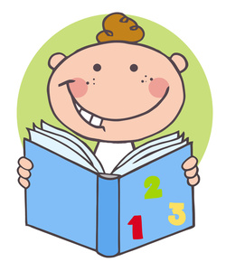

In order for your child to be ready to learn when he enters pre-school or kindergarten, it is important to make sure that he has a complete check-up by his medical provider. The medical provider will probably do a physical. She should check his hearing using either the audiometer or an OAE machine. She will also complete a vision examination. She will ensure that all of the immunizations are up to date. She may complete a developmental screening. She will indicate if there are any concerns or any follow- up needed by specialist or by the school.

**The ABCs of Literacy**

Exposure to language builds vocabulary and is a key factor to literacy success. Children with rich vocabularies typically do well in reading which leads to success in school.

What is early literacy? Early literacy is what young children know and learn about reading, writing, listening, speaking and understanding before they can actually read or write. All of the different areas of development are involved.

Intellectual – understand the meaning of words and that letters are symbols for sounds and words

Social Emotional – reflect the feelings and emotions between the child and others

Motor – ability to hold a pencil or turn pages in a book

Language – understand the sounds of spoken language and that words consists of a combination of sounds

Some early literacy skills include oral language development, phonological awareness, listening skills, conversational competence, book awareness, print interest, attention to book content, pre-writing and letter awareness.

There are two parts to language development: the ability to understand the words (receptive language) and the ability to put the ideas and feelings in words (expressive language).

Young children develop the ability to hear and distinguish the sounds and rhythms of the language that they are exposed to.

Reading and writing skills develop together. There are stages of reading and writing that each child will go through. For example, the writing may range from random marks, lines, scribbles, and zigzag lines to letters.

Many teachers in both day cares and schools incorporated activities in their classrooms to celebrate reading. This is great, but the ideal time to start reading to a child is before they are born. An unborn child is not going to understand the story, look at a picture or turn a page. What they are getting is a chance to hear your voice, which is something that they love. This starts the attachment process even before they are born. They also will begin life feeling good about reading.

There have been studies done on the benefits of reading and exposing children to good quality books. One result that stands out is reading to young children promotes achievement by teaching them to **want** to read. There are several factors that affect reading success. These include the value of literacy in the home, the amount of time that is spent reading with your child, and the availability of as well as the use of various reading materials in the home.

Reading to young children helps with many skills. Children learn about communication by hearing you talk. Children recognize pictures and the words that go with it. They learn new vocabulary words and how to put sentences together. Did you know that a young child could recognize the noun and verb order before they are one year of age? Children’s memory is improved. It provides them a way to understand their world while learning about routines, objects, places, and people. Social emotional skills such as attachment are built, as they like to spend time with you and hear your voice. Reading can also affect a child’s mood by calming them down when they are active or helping them to slow down and get ready for bedtime. It can help to cheer up a child when they are sad. Reading also helps children to understand and label feelings that they or others may display.

Reading with your child and talking about the book will help him fain competencies that are needed for school. These competences include, imagination, vocabulary and comprehension skills. It helps improve listening skills that leads to reading comprehension. Reading helps children to develop larger vocabularies and demonstrates phonological awareness. It can also help children to identify and write their name and letters. Many children who start school without these early literacy experiences and skills may never catch up to their peers.

Factors that promote language and literacy include reading to a child on a regular basis as part of his daily routine. Let him explore the book by looking at it and by naming or pointing to pictures that are in it. Have a variety of literacy materials available such as books, magazines, newspapers and paper/pencils for writing. Let your child see you being a role model for reading who has a positive attitude toward literacy and education by answering those endless questions they have and offering praise for their attempts at reading and writing.

One challenge that some families face which affect literacy in the home is that they are unable to read very well themselves. If that is the case, then you can still offer early literacy experiences to your child by reading the book through talking about what is happening in the pictures. Others challenges include the lack of time to read aloud and limited access to children’s books or not being familiar with good quality children’s books. One way to find those books is to visit the local library and check out children’s books. If you don’t have a library card you can request one. When reading a book you do not have to read it word for word especially with young children who have a very short attention span.

When adding books to the home ask yourself some questions:

* Is it age appropriate?
* Is it sturdy enough for young children to handle?
* Is it interesting for a child, does it draw their attention so that they will pick it up to explore?
* Will it bother you if they want to read it 10 times a day?

When reading to your child, use sound effects, facial expressions and pretend voices. Ask simple questions like what is happening in the picture or what do they think will happen next. Let them fill in words at the end of rhymes or tell you the story as they look at the pictures. Listen to the stories that they make up. Sell your child on reading by letting them see that it is a fun pastime just like those computer games they enjoy playing.

## Get a Healthy Start for School

Reading Helps Children Succeed

***Ease School Transition Through Preparation***

There are many resources available that will help parents get their children ready for school whether it is preschool or kindergarten. What is often seen as preparing for school is meeting the classroom teachers, getting the supplies that may be needed, etc. But one preparation is often overlooked and that is the parent’s preparation. It is just as important for the school transition to be a success as the child’s preparation.

Children get their cues for the appropriate way to behave in and their reactions to new situations from those who are around them especially their parents. If we want our child to be confident and prepared to enter school, then we as parents have to be confident and prepared. There are many transitions that they will go through while they are in school. These include not only following new routines during the day but also progressing from grade to grade, meeting new teachers, making new friends, and moving to new schools.

One way that you can help to make the transitions go smoothly is to think about what they are experiencing and plan for the future. Build and strengthen the home-school partnership by being an active partner with the school. Here are some ways that you can help to build that stronger partnership.

* Get to know the people who are around your child in the school through open communication. Remember they are his support system and if you have built a relationship with them, you will feel comfortable talking with them if you have any concerns about your child.
* Involve others who care for your young child in the process of entering preschool or kindergarten.
* Share information that is relevant to your child – health, learning styles, likes or dislikes, personality, etc – with his school and classroom teacher. This may solve problems even before they occur.

***Strategies to Support Language and Literacy***

There are many things that we can do to help support the development of language and literacy in young children. One way that we can begin to support language and literacy is by singing, talking and reading to the baby even before he is born. After birth we continue to do these activities with the baby, but we also can begin playing little simple games with them such as peek-a-boo or pat-a-cake. When a baby begins to make sounds, repeat the sounds back to him and carry on those little reciprocal vocalizations as if they are conversations. Talk about everything that you are doing with the child and label actions as well as objects using descriptive words. Use a variety of words instead of always using the same one. For example, when he is building with blocks and stacks them, you can use words like tower or skyscraper. Encourage conversations when you are looking at books. Talk to your child about what he is hearing, smelling, eating, touching or seeing. Encourage older toddlers to draw or scribble. Do finger plays and rhymes as well as singing songs.

***Books for Young Children***

There are different types of books for young children with each being better for each stage of development. For infants up to the age of six months, the best types of books include those with simple large pictures with bright colors. They may be “chunky” books that can be propped up, or they could be vinyl or cloth which could be washed or go into the bath. Infants from six to twelve months also like those “chunky” books with pictures of other children or familiar objects such as balls. At this age many books will go to the child’s mouth so you don’t want books that have thin pages as in a novel that you would read. Toddlers between the ages twelve and twenty four months like those sturdy books that they can carry. Their books should have a picture with only a few words on a page. Those with simple rhymes are good. Older toddlers ages two to three years like books that will tell a simple story. They also like books that they can memorize (simple rhyming books) or books with their favorite characters such as Dora. Four and five year olds like books about colors, shapes, counting and the alphabet. They also like books that are predictable or have repetition and rhyming.

**Share Books with Children**

Books can be a lot of fun for young children. There are several ways that you can help your child to learn to enjoy books.

Read or share stories each day with your child. A good time to do this is at bedtime.

As very young children are only able to sit for short periods of time to hear a story read, talk about what is happening in the pictures. It is okay if you are not able to read the whole story.

Let your child help turn the pages in the book.

Ask your child to point to different items in the pictures.

You can run you finger along the words as you read them showing the children that we read from left to right.

Help the story to come alive by changing your voice for the different characters or using your body to act the story.

Use stories that you read to talk about familiar activities and objects.

Ask questions and let your child answer them. Remember to ask questions that can require more than a yes or no or a one-word answer. Let your child ask questions also.

Let your child tell the story (even if it is not the way the story is written).

|  |  |  |  |  |  |
| --- | --- | --- | --- | --- | --- |
| 1-4 months |  | 16-20 months |  | 36-48 months |  |
|  |  |  |  |  |  |
| Sing to your baby. Repetition | | Place your child's clothing on | | When reading or telling a | |
| of songs and lullabies helps | | the bed before dressing. Ask | | familiar story, stop and leave | |
| your baby to learn and listen. | | for him to give you the ____. | | out a word. Allow your child | |
|  |  | This is an easy way to learn | | to fill in the missing word. | |
| 4-8 months |  | the names of everyday items. | |  |  |
|  |  | 20-24 months |  | 48-60 months |  |
| Play peek-a-boo with hands, | |  |  |  |  |
| cloth or a diaper. Cover your | | The body parts song, "Head, | | Encourage your child to learn | |
| face and let your baby pull | | Shoulders, Knees and Toes" | | their full name, address and | |
| the cloth away. Then let your | | is a good way to learn body | | telephone number. Make it | |
| baby hide. Take turns. | | parts. You can get more | | into a singing or rhyming | |
|  |  | detailed by naming other | | game for fun. Don't forget | |
| 8-12 months |  | body parts as well (teeth, | | to help them to learn mom | |
|  |  | eyebrows, mouth, etc). | | and/or dad's name as well | |
| Make a simple puzzle for | |  |  | (instead of mommy or daddy). | |
| your baby using blocks or | | 24-30 months |  |  |  |
| small ping pong balls. Place | |  |  |  |  |
| them inside of a muffin tin | | Add actions to your child's | |  |  |
| or egg carton. |  | favorite nursery rhymes. | |  |  |
|  |  |  |  |  |  |
| 12-16 months |  | 30-36 months |  |  |  |
|  |  |  |  |  |  |
| Play the naming game. Name | | Make a poster of your child's | |  |  |
| everything: body parts, toys, | | favorite things. Use old | |  |  |
| people, etc. This helps your | | magazines to cut out pictures | |  |  |
| baby to know that everything | | and glue to the poster paper. | |  |  |
| has a name and it will help | | Use safety scissors and glue | |  |  |
| her to begin learning the | | stick to allow your child to | |  |  |
| names. |  | complete poster by himself. | |  |  |
|  |  |  |  |  |  |

**Hoke County Public Library**

***Offers programs for children. Call (910) 875-2505 for more information about their upcoming programs.***

CALENDAR

July

National Parents Day 28

National Make a Difference with Children

Month

August

Get Ready for Kindergarten Month

September

National Grandparents Day 8

Family Day 25

Baby Safety Month

National Childhood Obesity Awareness

Month

Library Card Sign Up Month

National Hispanic Heritage Month

(9/15-10/15)

*Here are some activities that you can do with your young child. These will help in the development of skills in all areas of development. All of these are free and no materials need to be purchased. Just use items that you have around your home. Have fun!!*

*Hands On*

*Learning*

*Activities*

***Arts-n-Crafts***

Homemade Paint

½ teaspoon vinegar

½ teaspoon cornstarch

10 drops of food coloring

Place all ingredients in a jar and shake well.

Puffy Paint

¼ cup flour

¼ cup salt

¼ cup water

Food coloring

Mix the equal amounts of flour, salt and water. Add food coloring to make the desired color. Pour into small jar. Use brush to paint with. (When dry, the paint will puff up and has a bumpy feeling.)

Scribble Cookie

Take broken crayon bits in various colors and put in a muffin tin. Melt in oven just until the colors run together. After cool, pop out and you will have multi-colored crayons to color with.

Glitter

¼ cup salt

4-5 drops of food coloring

In a bowl, mix salt and food coloring. Spread salt in a thin layer on a plate and microwave for 1 minute until mixture is dry. (Put a cup of water in the microwave with the plate to protect your microwave.) Store in a glitter shaker or old spice container. Shake on arts and craft projects as you would glitter.

Playdough

2 cups flour

1 cup salt

Water

Small package of koolaid

Oil, optional

Mix the flour, koolaid, salt and water in a bowl. Add a small amount of oil if you do not want the play dough to harden. Knead the play dough a little and watch the little ones have fun.

Fruit Parfait

Layer low-fat vanilla yogurt, fruit and granola in a small bowl. Repeat the layers. Enjoy. (use any type of fruit that you like – berries, bananas, etc.)

Pizzas

What you need:

* Small corn tortillas
* Salsa
* Shredded cheddar cheese

Place a little salsa and cheese on each tortilla. Cook on foil-lined tray in a toaster oven until the cheese has melted and is brown at the edges.

Watermelon Popsicles

What you need:

* 2 ½ cups watermelon with seeds removed

Blend the watermelon in a blender and pour the mixture into popsicle trays. Freeze for 3-4 hours until pop is frozen solid. Defrost for about 5 minutes before removing popsicle from tray.

Smoothies

What you need:

* 1 cup milk
* 1 cup banana
* 1 cup fruit (your choice)
* 1 cup vanilla yogurt

Blend all together in blender.

COOKING CORNER

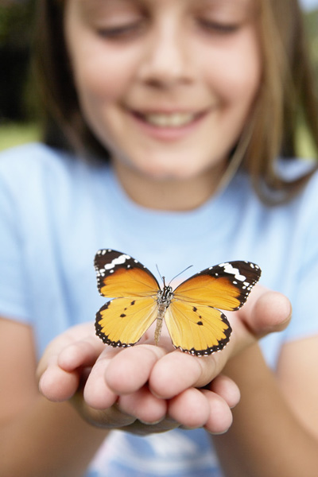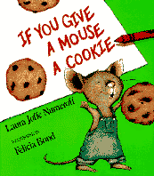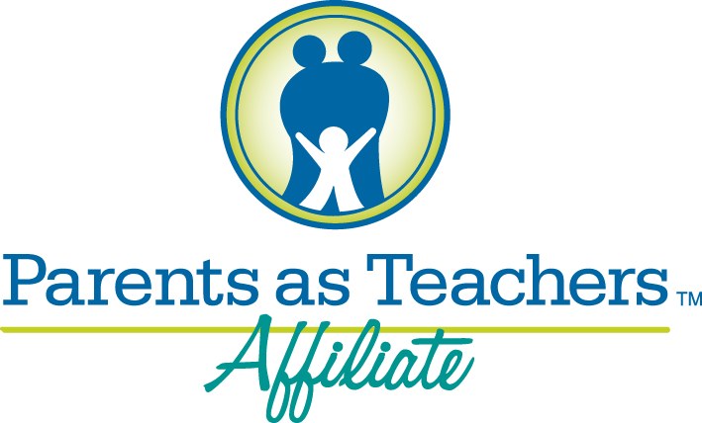

WORD SEARCH

LITERACY WRITING FINGERPLAYS

BOOKS LANGUAGE SPEECH

SIGNS READING SONGS

ALPHABET

|  |  |  |  |  |  |  |  |  |  |  |  |
| --- | --- | --- | --- | --- | --- | --- | --- | --- | --- | --- | --- |
|  |  |  |  |  |  |  |  |  |  |  |  |
|  | F | I | N | G | E | R | P | L | A | Y | S |
|  | W | D | W | A | S | F | H | G | L | P | P |
|  | T | G | R | H | Y | M | E | S | P | N | E |
|  | B | L | I | R | J | K | B | C | H | M | E |
|  | L | I | T | E | R | A | C | Y | A | C | C |
|  | M | A | I | S | L | S | S | B | B | S | H |
|  | T | U | N | I | M | E | O | 0 | E | W | D |
|  | O | M | G | G | A | N | N | 0 | T | H | G |
|  | K | K | V | N | U | L | G | K | I | G | N |
|  | A | L | Q | S | E | A | S | S | L | S | M |
|  | R | E | A | D | I | N | G | H | P | D | Y |
|  | E | R | T | H | Z | R | Y | E | B | R | T |
|  |  |  |  |  |  |  |  |  |  |  |  |

***If You Give a Mouse a Cookie***

*Written by Laura Joffe Numeroff and Illustrated by Felicia Bond*

This book is about a little boy and a mouse that wants a cookie. When he gets the cookie, he wants milk. After he receives what he wants he will ask for another item. As you read the story, your child can try to predict what the mouse will want next.

Hoke County Parents As Teachers

Summer 2013

Hoke County Parents As Teachers

116 West Prospect Avenue

PO Box 578

Raeford, NC 28376

Phone (910) 875-2000

Fax (910) 875-9044

Email:

brenda_currie@ncsu.edu

glorimar_santiago@ncsu.edu

*Parents As Teachers is a free and voluntary family support program for parents with children ages 0-5 who live in Hoke County. PAT has certified parent educators, both English and Spanish speaking, who provide individualized personal visits, group connection meetings, developmental screenings and is a resource network. We are located beside Turlington School in the Hoke County Cooperative Extension office.*

Vivamus id nisi vel purus gravida bibendum. Duis nec neque. In sem diam, convallis eleifend, rutrum id, rutrum et, justo. Cum sociis natoque penatibus et magnis dis parturient montes, nascetur ridiculus mus. Etiam malesuada eros at mi.