Newsarticle
Cyndi Lauderdale, Hort. Ext. Agent
June 9, 2013

Kudzu Bugs – First Appearance in the Wilson Botanical Gardens
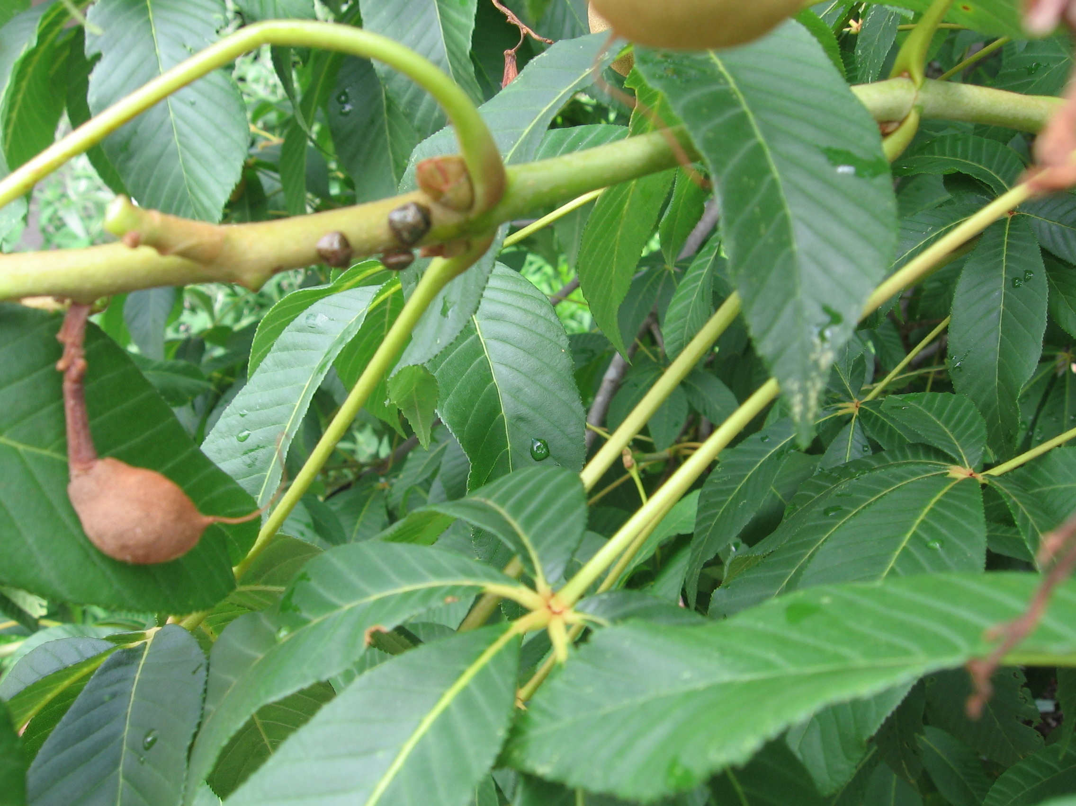
Kudzu bugs are a relatively new pest for North Carolina. They have been confirmed in patches of kudzu, soybean fields and other plants such as wisteria in 89 of the 100 counties in North Carolina. This year is the first sign of them in the Wilson Botanical Gardens. They currently have taken residence in our Buckeye Tree.
Kudzu bugs are approximately 1/4” oblong shape and olive-green in color with some brown speckles. They are similar in size to ladybugs. They have piercing-sucking mouthparts. While they don’t make holes in the leaves they suck nutrients and water from plant leaves and stems.
While most home gardeners will not see significant damage to their ornamental plants, this pest can be devastating to soybean and other bean crops. The Kudzu bugs have just finished the spring invasion of trying to enter homes. When temperatures cool again this fall Kudzu bugs will swarm and try to find a place to stay warm. They are attracted to light colors and may be seen on the eaves of homes. While spraying inside of homes for kudzu bugs isn’t recommended and timing of application outdoors is unpredictable, products containing pyrethroid (look for Active Ingredients that chemical name ends in “thrin” such as bifenthrin) will give some control.
For more information on kudzu bugs or any gardening related question call the Garden Helpline manned by Extension Master Gardener Volunteers on Mondays, Wednesdays, and Fridays from 1-3 PM or email them at wilsonemgv@hotmail.com. For additional information on kudzu bugs via the web see http://www.ces.ncsu.edu/depts/ent/notes/Urban/kudzubug.htm

