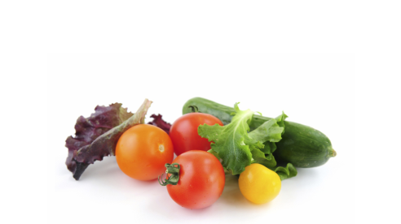
Sandhills Sustainable Ag SET Review
Handout 2 – Slide 11 of Module 7
Vision Statement Exercise
“Collaborative economic development efforts in the three-county region of Lee, Moore, and Richmond result in a vibrant agricultural sector as a critical component of creating a sustainable and self-reliant community. More healthy local foods are produced and consumed; numerous economically viable, food and non-food, entrepreneurial agribusiness opportunities are encouraged and supported, resulting in the average age of region farmers trending younger, agricultural lands and rural lifestyle are preserved long-term, and the health of community members is significantly improved.”

How is it relevant to the future? Imagine what the region will look like in 20-30 years.
______________________________________________________________________________________________________________________________________________________________________________________________________________________________________________________________________________________________________________________________________________________________________________________________________

Does it describe the values of the region?
______________________________________________________________________________________________________________________________________________________________________________________________________________________________________________________________________________________________________________________________________________________________________________________________________
Is it inspiring?
______________________________________________________________________________________________________________________________________________________________________________________________________________________________________________________________________________________________________________________________________________________________________________________________________
How do we distinguish it from every other region’s vision?
______________________________________________________________________________________________________________________________________________________________________________________________________________________________________________________________________________________________________________________________________________________________________________________________________

