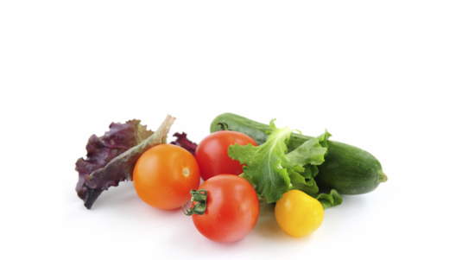
Sandhills Sustainable Ag SET Review
Handout 5 – Slide 18 of Module 7

Vertical Cluster

Product
Horizontal Cluster

