 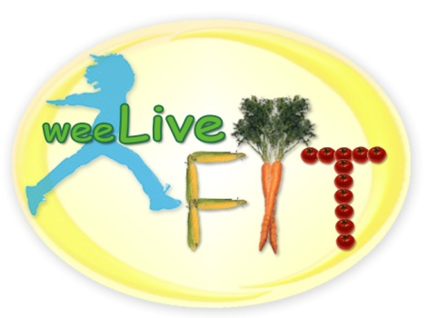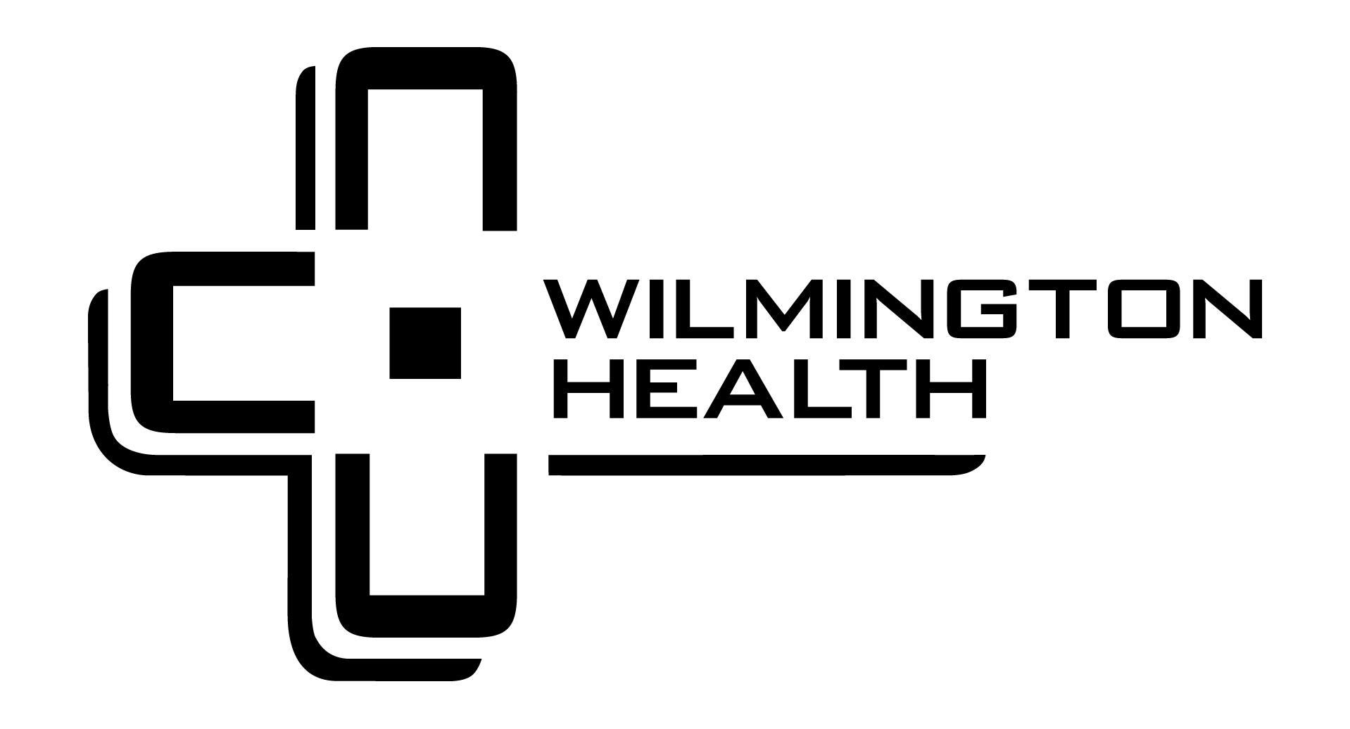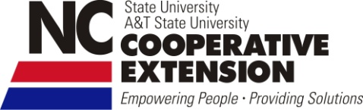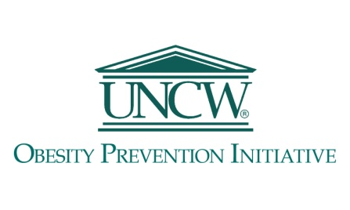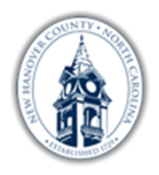

Join us for our 3rd Annual Childhood Obesity Summit where we will be discussing concrete resources in our community to combat this epidemic. You will be introduced to evidence-based tools you can use to be successful at home and help our community. This event is open to parents and professionals working with children. Portions of the HBO documentary, Weight of The Nation, will be used by both presenters to drive home their passion and knowledge.

**3rd Annual**

**Childhood Obesity Prevention Summit**

Addressing Childhood Obesity

**Tuesday, January 15, 2013**

**Presenters:**

**J’Nelle Ruscetti**, MS, PA-C; Masters in Science, at the Child Health Associate/ Physician Assistant program at University of Colorado Health Sciences Center. Practicing in the Family Medicine Division at Wilmington Health for the past 12 years, with a special interest in pediatric obesity since 2010 and implementation of the Family Fitness Challenge in January 2012.

**Chantel Welker**, MS, CHES; Masters in Food Science, Nutrition and Health Promotion at Mississippi State University.  Health Education Specialist employed with North Carolina Cooperative Extension, through NC State University, as an Extension Agent.  As a formerly obese child, she is interested in implementing healthy cooking interventions for families.

**Smart Start of New Hanover County 3534 S. College Road Suite F Wilmington NC 28412 910. 815. 3731 www.newhanoverkids.org**

**Program Time: 6:30– 8:30 PM**

**Location: New Hanover County**

**Government Center**

**Fee: $5 per individual**

**Early Childhood Professionals:**

Attendees at the Summit will receive 2 in-service hours through the Division of Child Development and Early Education sponsored by SSNHC.

And weeLiveFIT Collaborative Partners: Cape Fear Health Policy Council, Southeastern Preschool Education Center (SPEC), Total Childcare, SEAHEC, NHC Health Dept., New Hanover Regional Medical Center and Feast Down East.