Northern Guilford Middle and Guilford Elementary receive
Lowe’s Toolbox Education Grants this spring!
The Lowe’s Charitable and Educational Foundation has awarded a $3,000 Lowe’s Toolbox for Education® grant to Northern Guilford Middle School in Greensboro for the expansion of its garden club (a service learning club) The grant will be used to expand its greenhouse and raised garden beds. Northern Guilford Middle School is one of more than 500 schools across the United States to be awarded a Lowe’s Toolbox for Education grant for improvement projects during the
2014-2015 school year.

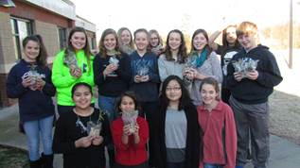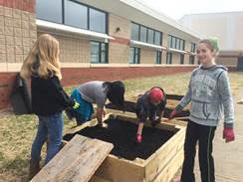
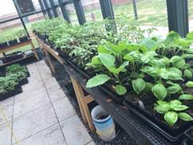

Northern Guilford Middle School’s garden club has been learning about food deserts and exploring strategies to help those in need. The garden club will use the grant money to expand its garden and upgrade its greenhouse. This year, the garden club raised vegetable plants from seeds for their garden. Extra plants were donated to other school gardens in Guilford County Schools. Over a 125 plants were donated. Produce raised in Northern Guilford’s garden will be donated to Share the Harvest. The Lowe’s Toolbox for Education grant will allow the garden club to expand this program. The garden will also be used for curriculum enrichment activities in all subject areas. The project is scheduled to be completed by the fall of 2015.

"The Lowe's Toolbox for Education program delivers on Lowe's commitment to improve the educational environment for students across the country," said Maureen Ausura, chairwoman of the Lowe's Charitable and Educational Foundation. "We're honored to work with Northern Guilford Middle School to support the needs of our local students, teachers and families." Parent groups and educators can apply by visiting ToolboxForEducation.com.

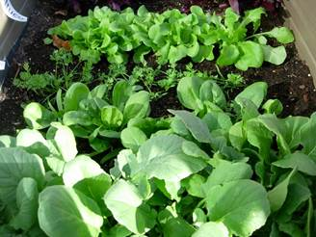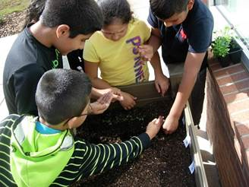
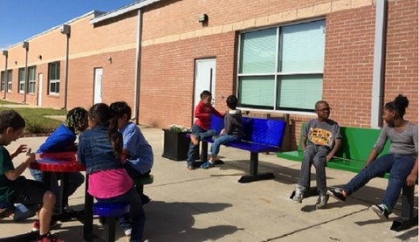
Guilford Elementary also received a Lowe’s Toolbox for Education this spring. Their grant is being used to provide a centrally located outdoor classroom and gardening boxes. Third grade teacher Thomas Gray described their plans to also build additional raised beds near the outdoor classroom. They also plan to engage in garden based service learning and donating their extra harvest to
their families and Share the Harvest. We can’t thank the Lowe’s Charitable and Educational Foundation enough for all of the support they have given over the years and continue to give to our Guilford County Schools!

