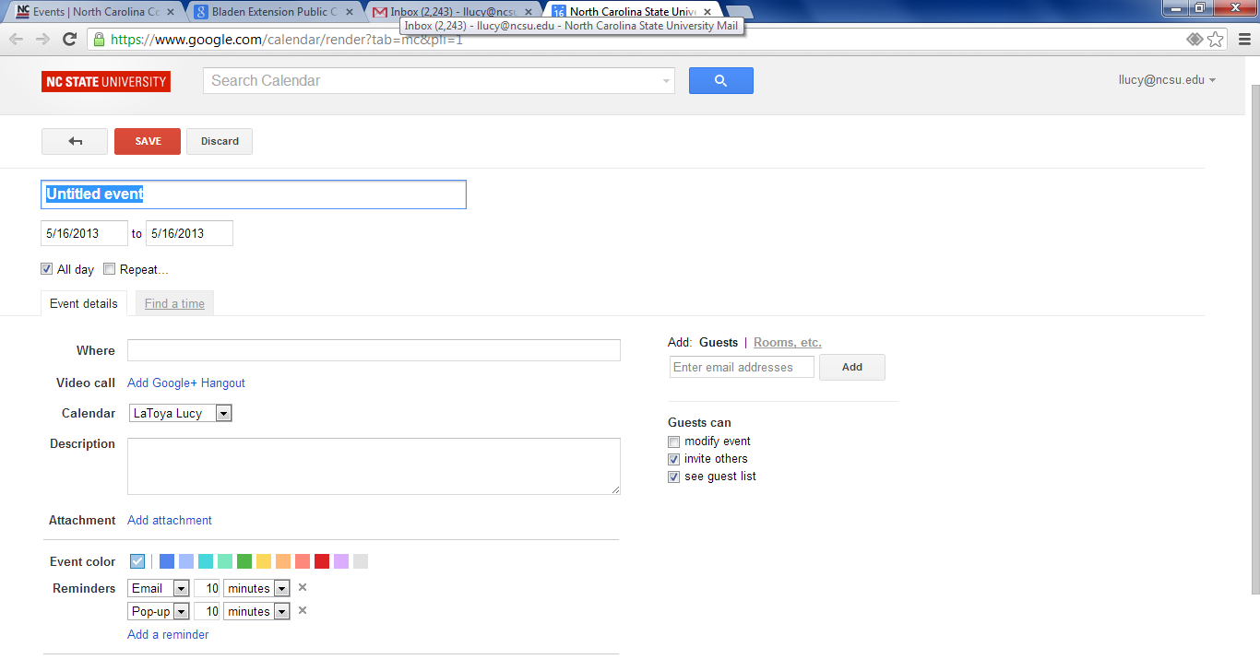

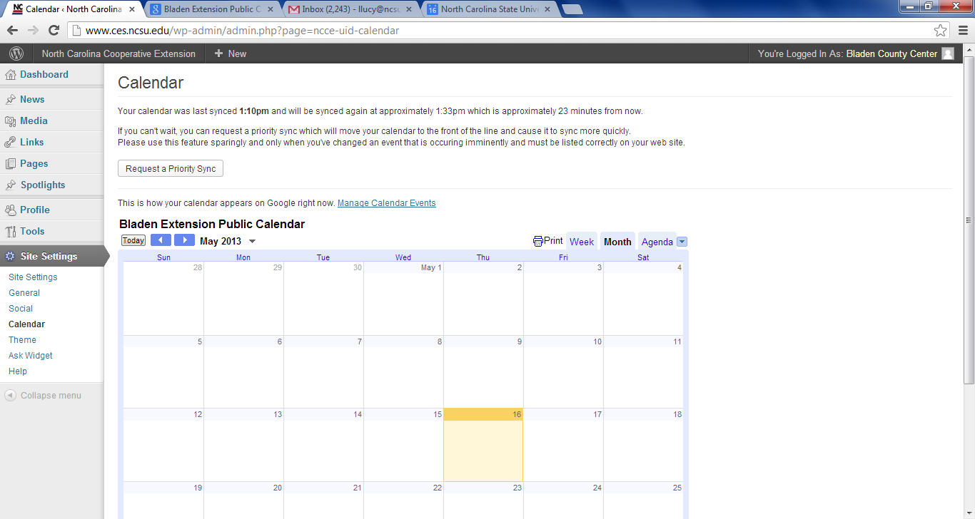
Where: put physical location so people will know where to find it at

Click on request a priority sync to get something on website immediately

When uploading pic to website you must provide text to describe what is being depicted. Disable people will be able to know whts in the pics using a special machine.

