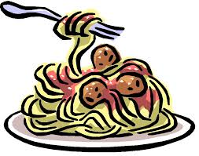

**Hayley’s Spaghetti Meat Sauce**

Ingredients:

* 2 pounds ground beef
* 1 large onion (or 2 small), chopped
* 2 (10 ounce) cans diced tomatoes
* 2 (15 ounce) cans tomato sauce
* 2 (14.5 ounce) cans stewed or peeled whole tomatoes
* 2 (6 ounce) cans tomato paste
* 1 package fresh sliced mushrooms
* 1 tablespoon Italian seasoning
* 1 tablespoon parsley flakes
* 1 tablespoon chili powder
* 1 teaspoon garlic powder
* 1 teaspoon basil leaves

Directions:

1. Combine ground beef, chopped onion, and mushrooms in a large pot. Cook and stir until meat is brown and vegetables are tender. Drain grease if needed.
2. Stir in diced tomatoes, tomato sauce, and stewed/peeled whole tomatoes into the pot. Add seasonings while sauce cooks down. Stir occasionally until warm.
3. ENJOY!!!