Wilson County 4-H Summer Fun

**June 16-August 13, 2014**



**4-H Teen Volunteer Training**

Date:June 16 Time: 10:00am-12:30pm

Ages: 12 & up Cost: No Cost

Location: Wilson Ag Center

Interested in serving as a teen volunteer this summer? If so, this class is for you. We are looking for teens to serve as assistants during our Summer Fun Day Camps. Anyone interested in helping out this summer is required to attend this training and commit to at least 5 hours of service.

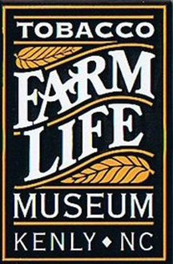**Tobacco Farm Life Museum**

Date: June 17 Time: 10:00am-2:00pm

Ages: 8 & up Cost: $8 and money for shaved ice ($3-$4)

Location: Wilson Ag Center

Supplies: Bagged lunch

Lets start summer off right! Enjoy the musuem and all it has to offer. We will step back in time

and make candles, discover artifacts, walk through the old school house, and enjoy a picnic lunch

under the shaded trees. Afterward, we will travel to Pelican Snowballs and enjoy a modern day

reat of shaved ice.

**Aurora Fossil Museum, Archaeological Dig, & Ferry Ride**

**FULL**

Date: June 19 Time: 8:00am-4:00pm (Leave promptly at 8 am)

Ages: 8 & up Cost: $6 & spending money

Location: Wilson Ag Center & Travel to Aurora, NC

Supplies: Sunscreen, Closed Toe Shoes, & Bagged Lunch

This is a great opportunity to get your hands dirty in the “dig” of a lifetime…sharks

teeth and other interesting fossils! You will also tour the fossil museum. We will have a

picnic lunch and ride the ferry after. Visit [www.aurorafossilmuseum.com](http://www.aurorafossilmuseum.com) to check it out!

**Boys Day In & Out**

Date: June 20 Time: 8:30am-2:30pm

Ages: 9-13 Cost: $8 and lunch money

Location: Wilson Ag Center

Hang out with the guys! Get ready to fish at a local pond, catch lunch at a fast food chain, and head back to the Ag Center for a visit from Wilson’s own Mounted Rescue Team. We will enjoy the rest of the afternoon working on a project everyone is sure to love.

**hr3a.gif**

**Cooking with Ms. Kris**

**FULL**



Date: June 24 Time: 9:00am-12:00pm

Ages: 5-8 Cost: $8

Location: Wilson Ag Center Kitchen

Come join us in the kitchen and find out how fun cooking really is! Step 1: Dress comfy and ready to work. Step 2: Bring a positive attitude and get ready to meet new friends. Step 3: Start Cooking. Step: 4 Enjoy!!!

**FULL**

**Wilmington Battleship & Fort Fisher**

Date: June 26 Time: 8:00am-4:30pm

Ages: 9 & up Cost: $10

Location: Wilson Ag Center & Travel to Wilmington, NC

Supplies: Sunscreen, Beach Towel, Comfortable Shoes, Bagged Lunch

Step back in time for a tour of the Battleship. Let history come alive through stories from the crew. Then we will head to Fort Fisher to discover more of North Carolina’s rich history while enjoying a picnic lunch.

**Exploring Farm Animals**

Date: June 30 Time: 9:00am-12:00pm

Ages: 8-13 Cost: $6

Location: Wilson Ag Center & Area farms  
Travel with one of our extension staff members to local farms to explore the variety of farm animals in Wilson County. You will have the opportunity to visit a swine, cattle, and even a horse farm! Don’t miss it!

C:\Documents and Settings\Administrator\Local Settings\Temporary Internet Files\Content.IE5\I0X9Z053\MC900353722[1].wmf

**Patriotic Picnic**

Date: July 1 Time: 9:00am-1:00pm

Ages: 7 & up Cost: $8

Location: Wilson Ag Center

Youth will make parade items, decorate their bikes and have a parade around the Ag center and Secret Garden. A patriotic lunch will be prepared. We will also travel to Spring Arbor to meet, greet, and parade for the residents. Lunch is provided.

bd05110_***Art Enrichment***

Date: July 7-11 Time: 9:00am-12:00pm

Ages: 8-18 Cost: $80.00

Location: Wilson Ag Center

Come and learn how to draw, shade, and create in a fun and loving atmosphere. Lynn Keenan is a remarkable artist and your instructor for the week. There will be an art show on the last day to show off your wonderful works.

MC900232553[1]**Cupcake Creations**

Date: July 7-10Time: 1:00pm-4:00pm

Ages: 7-15 Cost: $35

Location: Wilson Ag Center Kitchen

Instructor: Meagan Culkin

Campers will learn how to develop various skills in the kitchen including decoration techniques. This is a fun class and a great way to bring your artistic expression to life in the form of a very sweet treat.

**All participants must complete the 4-H Enrollment and Medical Release (medical release must be notarized) before participating in any class.**

**You can find these on the 4-H website along with the Summer Fun class registration.**

[**http://wilson.ces.ncsu.edu/categories/4-h-youth-development/**](http://wilson.ces.ncsu.edu/categories/4-h-youth-development/)

**Manufacturing Your Future**

Date: July 8-9 Time: 9:00am-3:00pm

Ages: 14-18 Cost: $10

Location: Wilson Ag Center

Have you ever thought of a career in the manufacturing industry? Manufacturing today is cutting-edge, cool, and profitable! During this class, we will learn about careers in manufacturing, visit area businesses, and talk about your future! Lunch is provided.

**FULL**

**BUG OUT**

Date: July 14 Time: 10:00am-1:00pm

Ages: 5-8 Cost: $6

Location: Wilson Ag Center

Don’t freak out…. Bug out!!! Come enjoy learning about bugs and their benefits to our environment. Crafts, games, and so much more! Lunch will be provided.



**Cooking with Ms. Kris, Too!**

Date: July 15 Time: 1:00pm-4:00pm

Ages: 9 & up Cost: $8

Location: Wilson Ag Center Kitchen

Let’s work together! This class will be based on teamwork! We will break off into teams

to create a meal, and then enjoy a bake off! Bring your imagination and your appetite.

**Health Rocks!**

Date: July 16 Time: 9:00am-3:00pm

Ages: 9-13 Cost: No cost

Location: Wilson Ag Center

Join us for a hands-on, fun-filled day where we will learn about healthy lifestyles. We will discuss how to avoid risky behaviors and the effects of alcohol and other substances. Lunch will be provided.

***Sylvan Heights Bird Park***

Date:July 17 Time: 8:30am-1:30pm

Ages: 9-18 Cost: $10 and lunch money

Location: Wilson Ag Center & Travel to Sylvan

Supplies Needed: Tennis shoes

Roam this 18-acre facility with over 200 duck, geese, swans, and exotic birds living in their outdoor natural habitat. You are sure to hear the call of the wild! This is a fun trip with our own Billy Little. Group will stop for lunch at Hardees.

**FULL**

**Farm Visit**

Date: July 25 Time: 9:00am-12:00pm

Ages: 8 & up Cost: $5

Location: Wilson Ag Center

Supplies: Comfortable shoes and Sunscreen

Have you ever visited a farm? Would you like to learn about crops?

We will visit a farm in Wilson County that grows tobacco, corn, cotton, sweet potatoes and soybeans to learn about these crops and how they grow. Participants will also be able to see tractors and equipment that farmers use to raise crops.

Dolphin Tour

Date: July 29 Time: 8:30am-5:00pm

Ages: 10 & up Cost: $30

Location: Wilson Ag Center & Outer Banks, NC

**FULL**

Supplies: Bagged lunch, sunscreen, & a towel (No bathing suits)

Join us on a unique eco-tour to search for wild Atlantic Bottlenose Dolphins. We will view the wildlife of the Outer Banks, while traveling by 40-foot pontoon boat, then we will enjoy a picnic lunch on the beach. This should be a fun day!

***Adventures in the Garden with Sandy***

Date: July 30 Time: 10:00am-1:00pm

Ages: 6-11 Cost: $7

Location: Wilson Ag Center

Supplies: Tennis shoes, sunscreen, a bagged lunch, & a beach towel

Participants will enjoy the day with the secret Garden Curator, Sandy Goetz. Use your imagination and “sea” the garden through pirate eyes! Get ready for crafts and fun while learning about all the garden has to offer.

**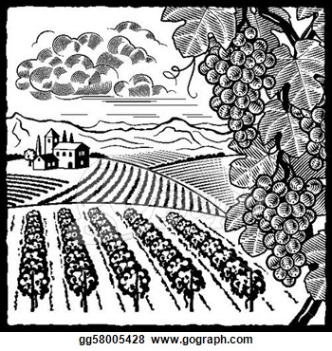Maple View Agricultural Education Center**

Date: August 5 Time: 8:00am-3:00pm

Ages: 8 & up Cost: $10 & spending money

Location: Wilson Ag Center & Travel to Hillsborough, NC

Supplies: Closed toe shoes, beach towel, bagged lunch, & sunscreen

Get a hands on education at this center. Learn about agriculture and sustainable farm life.

We will enjoy 2 interactive labs, a hayride, picnic, and so much more!



**Cloverbud Camp**

**FULL**

Date: Aug 6-8 Time: 1:00pm–4:30pm

Ages: 5-8 Cost: $20

Location: Wilson Ag Center

Supplies: Sleeping bag, flashlight, and closed toe shoes

Come enjoy a 3-day camp with Ms. Kris! We will enjoy crafts, snacks, educational fun, and games. This is a good way to enjoy the camping experience without ever really leaving home!

**Girls Day In & Out**

Date: Aug 12 Time: 9:00am-3:00pm

Ages: 9 & up Cost: $10

Location: Wilson Ag Center

Calling all Girls! Let’s get together! Pampering, crafts, chocolates, girl talk…you name it! We will have a blast and even step out in Wilson for an ice cold treat to cool down. What a great way to spend a hot summer day!

**MC900233051[1]End of Summer Fun Picnic**

Date: August 13 Time: 5:00pm-6:30pm

Cost: No Cost

Ages: All who participated in summer camps this summer

Location: Wilson Ag Center

Enjoy the evening with the 4-H staff and say goodbye to another fun filled summer. We will enjoy the afternoon playing games and eating some summer time favorites. Must have attended at least one summer fun camp. Register online or by calling the 4-H office (237.0113).



**4-H Camp**

Date: July 20-25th

Cost: $420 \*\*\*Scholarships available\*\*\*

Ages: 8-12 years old

Location: Eastern 4-H Center in Columbia, NC

Looking for a great adventure this summer? Then this camp is for you! 4-H camp is a weeklong adventure where participants will stay in a cabin, meet new friends, play outdoors, learn cool new stuff, and more, all while building life skills. Some camp activities at the Eastern Center include kayaking, rock wall climbing, swimming, marine science classes, crafts, ropes course, and more! Check out the camp’s website at: http://www.eastern4hcenter.org/ The Wilson County 4-H office will transport the campers and stay with them during camp week.

***For accommodations for persons with disabilities, contact the 4-H office, no later than 14 days before the scheduled class.***

**All participants must complete the 4-H Enrollment and Medical Release (medical release must be notarized) before participating in any class. You can find these on the 4-H website along with the Summer Fun class registration.**

[**http://wilson.ces.ncsu.edu/categories/4-h-youth-development/**](http://wilson.ces.ncsu.edu/categories/4-h-youth-development/)

**REMINDERS**

1. Please make sure that participants **arrive on time** to classes and are picked up on time! If there are field trips and they do NOT arrive on time…they may be left! No Refunds!
2. There will be a **sign-in and sign-out procedure** that everyone must follow…it is for your child’s safety.
3. Always **check class descriptions** to see what needs to be brought **and** where classes are going to be held.
4. Please **dress your child in appropriate clothing** for the classes (weather, planting, painting, etc.).
5. **REGISTRATION IS NON-REFUNDABLE.** Some classes require a minimum number of participants. If the 4-H office cancels an event, a refund will be given.
6. If you do not show up for a class…**you will NOT receive a refund**. If you do cancel, please give us at least a 48 hour notice to accommodate for others that might want to participate.

**Cell phones:** The staff member in charge of the workshop or camp will have a cell phone if a situation arises that we should need to contact anyone’s parents. Therefore, participants should not use cell phones during the class. Cell phones become a distraction to students and presenters. Please make sure every student understands this policy. Call the 4-H office in the event of an emergency and you need to get in touch with your child.

**Late Pickup/Early Arrival Policy**

You will need to drop off and pick up your children at the Wilson County Agricultural Center at 1806 SW Goldsboro Street for all 4-H Summer Fun Workshops. Please do not arrive more than 15 minutes early and plan to pick up your child on time. Early drop off and late pick up fees starting at $5.00 for each 15 minutes will be applied after **2** occurrences. Feel free to call the 4-H office with any questions at 252.237.0113.

**All events & activities operate under the 4-H Code of Conduct and Disciplinary Procedure. This 4-H Code of Conduct and Disciplinary Procedure is a condition of participation in any NC 4-H activities or programs. A copy may be obtained from the Wilson County 4-H Office or**

<http://www.nc4h.org/publications/forms/4-H_codeofconduct.pdf>**.**

**Failure to comply with Wilson County 4-H’s policies may result in exclusion from 4-H classes**

**North Carolina State University and North Carolina A&T State University commit themselves to positive action to secure equal opportunity regardless of race, color, creed, national origin, religion, sex, age, or disability. In addition, the two universities welcome all persons without regard to sexual orientation. North Carolina State University, North Carolina A&T State University, U.S. Department of Agriculture, and local governments cooperating**

**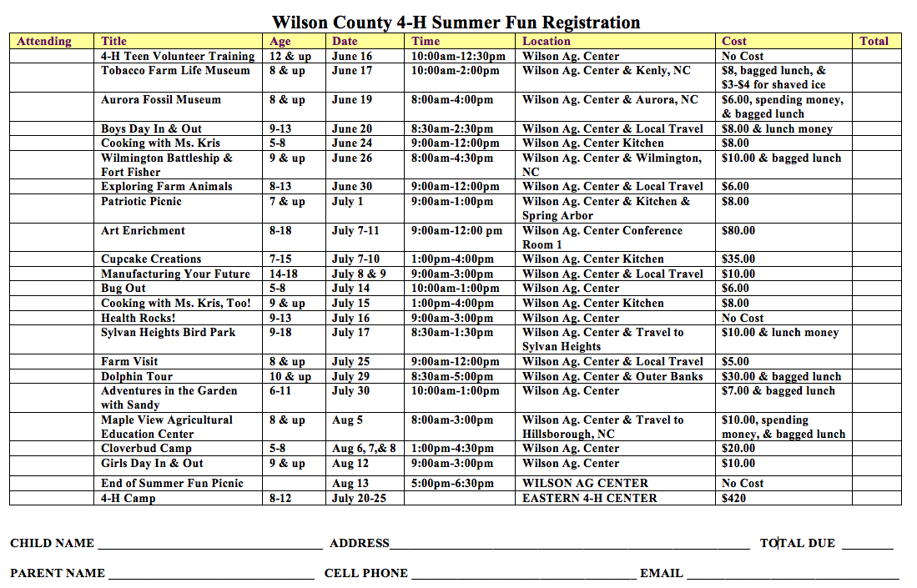**

You can register online at http://wilson.ces.ncsu.edu/categories/4-h-youth-development/ OR in person at the Wilson County 4-H office at 1806 SW Goldsboro St.