YOUR RESPONSES TO THIS APPLICATION ARE KEPT STRICTLY CONFIDENTIAL

If you have any questions, please feel free to contact Sarah Blacklin at sarah@ncchoices.com (919-928-4771). Space is limited. Please fill out the following application by October 10, 2014 and return via email or mail to:

Attention: Sarah Blacklin
Center for Environmental Farming Systems
Campus Box 7609/Kilgore Hall
Raleigh, NC 27695
sarah@ncchoices.com

Participation Application- Due no later than October 10, 2014
You May Attach Another Sheet of Paper If Needed
Name: _______________________________ Phone Number: ( )_____________

Address:______________________________________________________________

Email: __________________________ County: _____________________________

Age: ____________________________

Farm or Business Name: ___________________________________________________________

1. Tell us about your Farm/Business or the nature of your work in the meat industry: ______________________________________________________________________________________________________________________________________________________________________________________________________________________________________________________________________________________________________

2. Why are you interested in attending the Women Working in the Meat Business retreat?
______________________________________________________________________________________________________________________________________________________________________________________________________________________________________________________________________________________________________

3. Briefly explain what you would like to learn/ take home from the workshop:
______________________________________________________________________________________________________________________________________________________________________________________________________________________________________________________________________________________________________

4. I am a: Please circle one of the following

Farmer
Prospective Farmer
Meat Processor
Chef
Other Food Professional
Meat Buyer
Cooperative Extension
Other

If farmer, list the species you raise __________________________________

5. Estimate how many head of livestock you processed in 2013? If you have not and do not intend to process any livestock, you may answer N/A if this question does not apply to you
Swine________
Beef________
Poultry________
Lamb________
Goat________
Other________

7. How many years have you been involved in your meat operation? ________

8. I am also applying for April Schaeffer’s Leadership and Cattle Handling for Female Producers, Saturday, Nov.8th (Note: This requires a separate application): (Y/N)________

8. In order to maximize networking and accommodate all participants in the lodge, you will be sharing a room or common space with one or more women. Beds and air mattresses will be provided and sleeping arrangements will be determined at random. Please acknowledge that you have read and understand this arrangement with your signature. X____________________________________________________________________________________

Note: You will be notified by October 17, 2014 if you are selected to participate in the workshop. Notification *DOES NOT* reserve your spot. You will have to submit full payment or half deposit by Oct.27th to reserve your space.

*************************************************************************************
Complete This Section If You Are Applying For Scholarship
*************************************************************************************

Full and Partial Scholarships Available
Scholarship Application- Due no later than October 10, 2014

1. I am applying for: Please circle one of the following

Full Scholarship $400 Partial Scholarship $ Amounts may vary depending on need

2. If a full scholarship is not available, would you like to be considered for partial scholarship?_______

3. How many people are living in your home? _________

4. What is your approximate annual household income?_______

5. What is your ethnicity?________

6. What are your biggest barriers to attending the retreat and why?
_____________________________________________________________________________________________________________________________________________________________________________________________________________________________________________________________________________________________

7. Would you be willing to provide feedback and/or be featured in media (online, newspaper, video) representing NC Choices, in order to improve this scholarship initiative in the future? (Yes/No) ______

8. Would you be willing to share your experiences with other women in the industry? (Yes/No) ______

Feel free to share any additional information about yourself that might help us in our consideration.
______________________________________________________________________________________________________________________________________________________________________________________________________________________________________________________________________________________________________
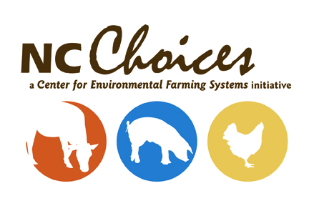

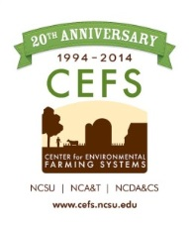
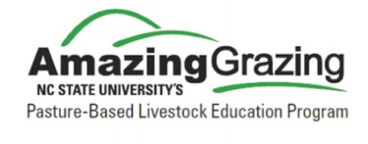

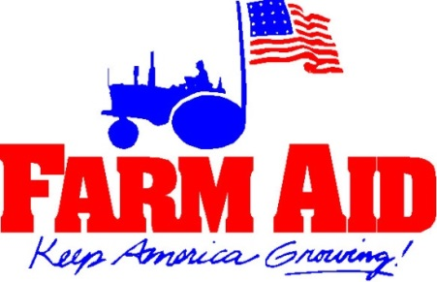
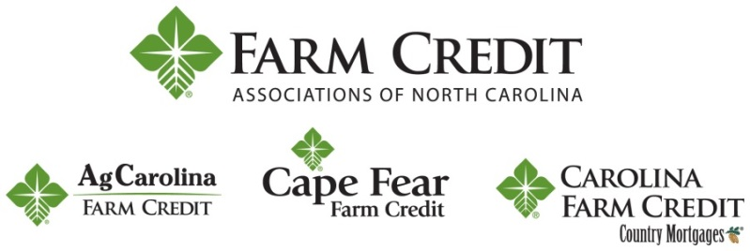
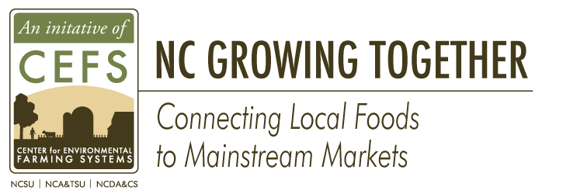
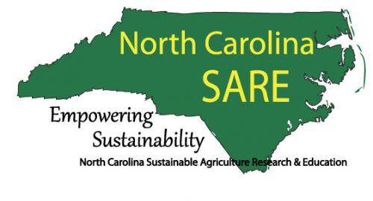
With Support From:

