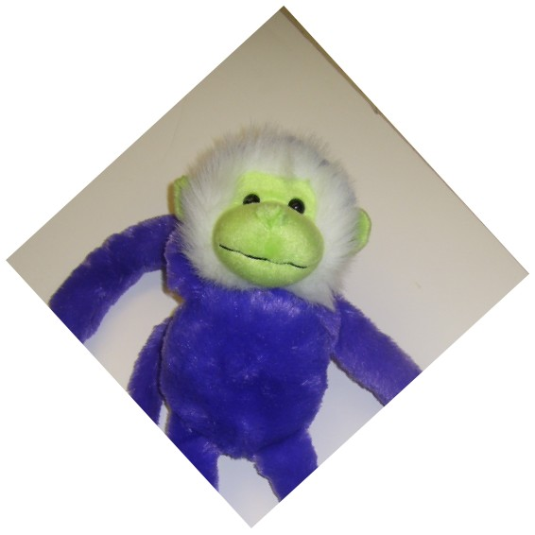
Get the
Money Monkey
Off Your Back!!
SERIES OF 5 CLASSES

- Do you want to pay your bills on time?
- Would you like to save money?
- Always scrambling for a quick fix for finances?
You get: Activities, Info & Worksheets, Prizes, Snack
STOP
Going Bananas &
Attend!

Location:
ACIM
634 Roxboro Road
Oxford, NC

Dates/Time:
Tuesdays, February 24, March 3, 10, 17 and 24 from 6-8 p.m.

ALL INCOME LEVELS
WELCOME!

Cost:
Your Time and Attention

Sponsored by:
Area Congregations in Ministry (ACIM)
North Carolina Cooperative Extension-Granville County Center

REGISTER BY February 17, 2015
To register or for more info: Call ACIM at (919) 690-0961
or the
Granville County Extension Center at (919) 603-1350.

Learn to:
- Evaluate your current financial situation
- Set goals
- Buy only what you need
- Start a savings program (yes, you can save money!)
- Set up a financial record-keeping system

Get the Money Monkey
Off Your Back!!

Registration Form

CLASS LOCATION: 634 Roxboro Road, Oxford, NC
Name(s)
Address

Phone
Email Address

Tell us why you want to attend. Check all that apply:
- To learn to budget my money to pay bills.
- To be able to save money.
- To be able to save to buy a house.
- To save for my retirement years.
- To feel better about my money.
- Other:

Deliver by February 17, 2015 to:

Sue Hinman, ACIM
P.O. Box 398, 634 Roxboro Rd., Oxford, NC 27565

North Carolina State University and North Carolina A&T State University commit themselves to positive action to secure equal opportunity regardless of race, color, religion, creed, national origin, sex, age, disability, or veteran’s status. In addition, the two Universities welcome all person without regard to sexual orientation. North Carolina State University, North Carolina A&T State University, U.S. Department of Agriculture, and local governments cooperating.

Persons with disabilities and persons with limited English proficiency may request accommodations to participate by contacting Paul Westfall, County Extension Director, at 919.603.1350, or paul_westfall@ncsu.edu, or fax 919.603.0268, or in person at the County Extension Office at least 7 days prior to the event.

